The polycentric area of the Eastern Veneto Region

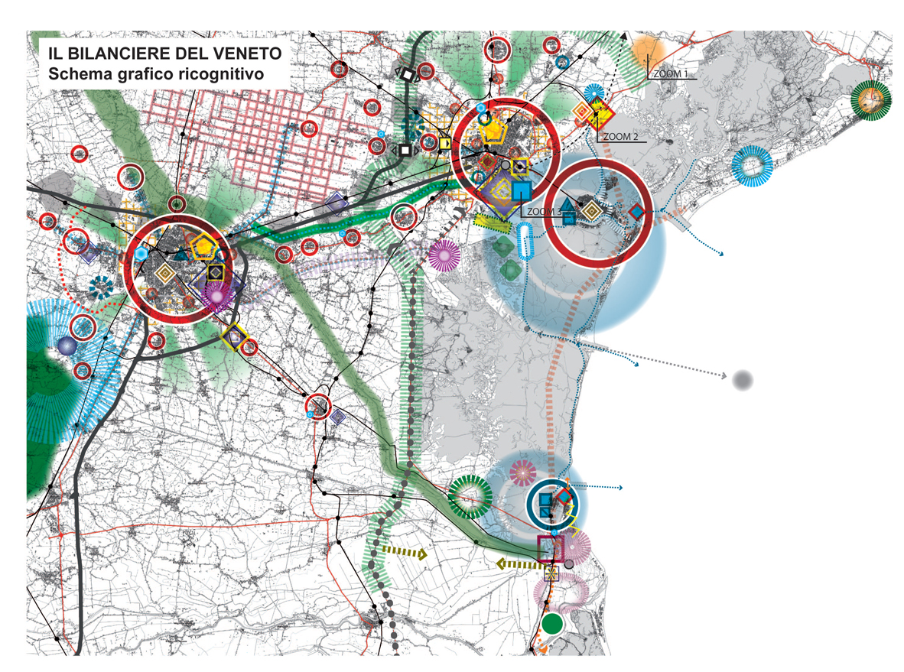
Area of MESTRE and VENICE PORT
City of VENICE
City of PADUA
Airport “MARCO POLO”

56

56

