

Compilation of emission inventories for five large Mediterranean cities: Barcelona, Genoa, Marseille, Thessaloniki and Venice


Scientific Responsible:

Melas Dimitrios
(Aristotle University of Thessaloniki)

Contribution from:

Markakis Konstantinos, Liora Natalia, Poupkou Anastasia
(Aristotle University of Thessaloniki)

Fernández Bautista Pedro
(EUCC Mediterranean Centre)

Armengaud Alexandre, Piga Damien
(Atmo-PACA)

Brotto Paolo
(University of Genoa)

Susanetti Laura, Pillon Silvia, Elvini Elena, De Vettori Stefania, Liguori Francesca
(Environmental Protection Agency of Veneto Region)

Table of contents

Summary

- Barcelona

  - Short Description of the Methodologies for the Estimation of Emissions for all Source Sectors except for the Maritime Sector
  - Description of the Methodologies for the Estimation of Emissions for the Maritime Sector
  - Anthropogenic Emission Inventory Results for Barcelona

- Genoa

  - Short Description of the Methodologies for the Estimation of Emissions for all Source Sectors except for the Maritime Sector
  - Description of the Methodologies for the Estimation of Emissions for the Maritime Sector
  - Anthropogenic Emission Inventory Results for Genoa

- Marseille

  - Short Description of the Methodologies for the Estimation of Emissions for all Source Sectors except for the Maritime Sector
  - Description of the Methodologies for the Estimation of Emissions for the Maritime Sector
  - Anthropogenic Emission Inventory Results for Marseille

- Thessaloniki

  - Short Description of the Methodologies for the Estimation of Emissions for all Source Sectors except for the Maritime Sector
  - Description of the Methodologies for the Estimation of Emissions for the Maritime Sector
  - Anthropogenic Emission Inventory Results for Thessaloniki

- Venice

  - Short Description of the Methodologies for the Estimation of Emissions for all Source Sectors except for the Maritime Sector
  - Description of the Methodologies for the Estimation of Emissions for the Maritime Sector
  - Anthropogenic Emission Inventory Results for Venice

- Summary Tables Describing Methodologies and Data Used for the Estimation of the Maritime Sector Emissions for Each Study Area

- Synthesis

  - Comparison of Emission Results
  - The Maritime Sector Methodology

Annexes

References

URLs

Summary

In the framework of the APICE project within the EU Med Programme, emission inventories have been prepared for five Mediterranean port-cities: Barcelona, Genoa, Marseille, Thessaloniki and Venice. The preparation of the emission inventories included either the processing of existing updated emission data or the estimation of emission fluxes with the use of updated activity data and calculation methodologies published in the recent scientific literature. The emission inventories compiled account for gaseous (mainly carbon monoxide (CO), nitrogen oxides (NOx), sulfur dioxide (SO2), ammonia (NH3) and non-methane volatile organic compounds (NMVOCs)) and particulate matter (PM10 and PM2.5) emissions from all anthropogenic emissions sources (e.g. transport, industry, energy, central heating etc). Emphasis has been given on the detailed calculation of emissions from ships and other activities in the harbor area. In addition, natural emissions have been estimated for the study areas including biogenic NMVOCs, windblown dust and sea salt emissions.

This report has been written in order to provide more information on the methodologies used for the compilation of the emission inventories for each port-city. The report is more detailed in the presentation of the methodologies used for the maritime sector emissions. In the report, the anthropogenic source sectoral contribution to pollutant emissions is shown for all areas studied. In addition, the common features and differences between the anthropogenic emission inventories for the study areas are identified. The report is accompanied by five Excel files showing results from the compilation of the anthropogenic and natural emission inventories in the form of tables and maps.

- Barcelona

  - Short Description of the Methodologies for the Estimation of Emissions for all Source Sectors except for the Maritime Sector

The Barcelona area inventory has been done in two geographical scales. Firstly, a general inventory for a surface of 100x100 km around the city of Barcelona, with 50km resolution, for the year 2008. Emission data has been retrieved from the EMEP website for all the SNAP categories, taking into account four emission cells (67,21; 67,22; 68,21; 68,22). A more detailed inventory covering two air special protection zones (approximately 1.500 km²) has been elaborated using mainly data provided by the Government of Catalonia. This inventory focuses on NOx and PM10.

Energy production

Facilities for energy production are obliged to declare their emissions to the Catalan administration according to the forms available at its website http://www20.gencat.cat/portal/site/dmah/menuitem.8f64ca3109a92b904e9cac3bb0c0e1a0/?vgnextoid=8f6075a37c927210VgnVCM1000008d0c1e0aRCRD&vgnextchannel=8f6075a37c927210VgnVCM1000008d0c1e0aRCRD&vgnextfmt=default

As for this SNAP, the categories “energetic” and “combustion and cogeneration” facilities have been considered (the Catalan registry includes them as industries).

Central heating

It is calculated considering the total consumption (coal, gas-oil, natural gas, glp and fuel oil) in Catalonia (source: Pla de l’Energia de Catalunya) and total population, so the consumption/inhabitant is calculated. Then, considering the population in each municipality within these zones, the emissions per municipality are calculated and then added to obtain consumption per municipality. Finally, the following emissions factors are applied (Oficina Tècnica de Qualitat de l’aire 2011, pers.comm.)

Industries

Most important industrial facilities are obliged to declare their emissions to the Catalan administration according to the forms available at its website http://www20.gencat.cat/portal/site/dmah/menuitem.8f64ca3109a92b904e9cac3bb0c0e1a0/?vgnextoid=8f6075a37c927210VgnVCM1000008d0c1e0aRCRD&vgnextchannel=8f6075a37c927210VgnVCM1000008d0c1e0aRCRD&vgnextfmt=default

As for these two SNAPs, the categories “industry” and “asphaltic” facilities have been considered. See Annex I for more information.

Other mobile sources and machinery

Airport emissions

- Auxiliary Power Unit (APU) emissions are estimated following the procedures and methods of the EDMS model of the FFA. These emission data are provided by the airport of Barcelona.

- Ground Support Equipment (GSE) emissions are calculated using the EMEP simple methodology.

- Aircraft emissions are calculated following the methodology for LTO cycles.

  - Description of the Methodologies for the Estimation of Emissions for the Maritime Sector

Methodology for ship emissions

1. Find the correspondence between the ships typology used in the port with that used at CORINAIR 2009 (EEA, 2009):

Port of Barcelona typology | Corinair 2009 typology
CAR-CARRIER | General cargo
CARGA (LO-LO) | General cargo
FRIGORIFICO | General cargo
GRANELEROS | Dry bulk carriers
PASAJE | Passenger
PETROLEROS | Liquid bulk ships
PORTACONTENEDOR | Container
RO-RO | Ro-Ro cargo
TANQUES | Liquid bulk ships
TRANSBORDADORES | Passenger
TRANSB. ALTA VELOCIDAD | Passenger

2. Number of stopovers of each ship, gross tonnage (GT), manoeuvre time, tied up time (source: Port Authority)

3. Regarding installed propelling power of the main engine and electric auxiliary power, Corinair estimations methodology is applied (Tables 3.12 and 3.13 of the CORINAIR 2010, version March 2011).

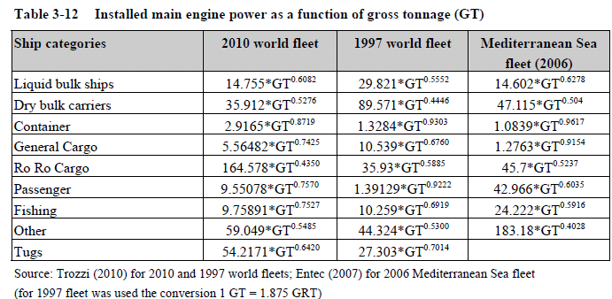

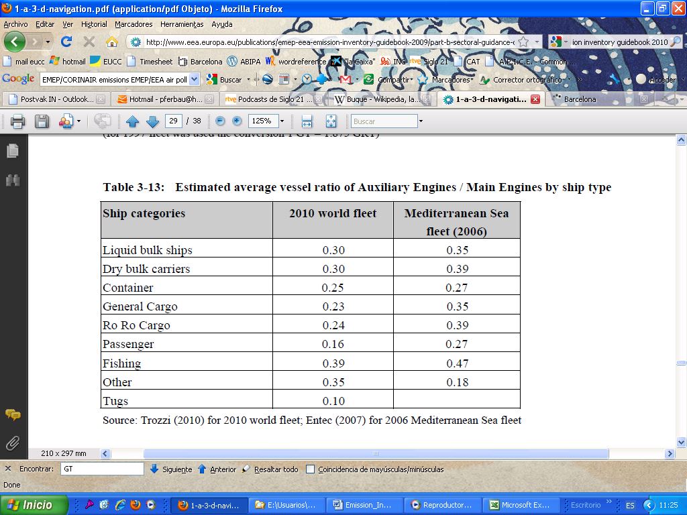

4. The ships stopovers are distributed according to fuel type and engine type (Table
3.7 of the CORINAIR 2009, version June 2010)
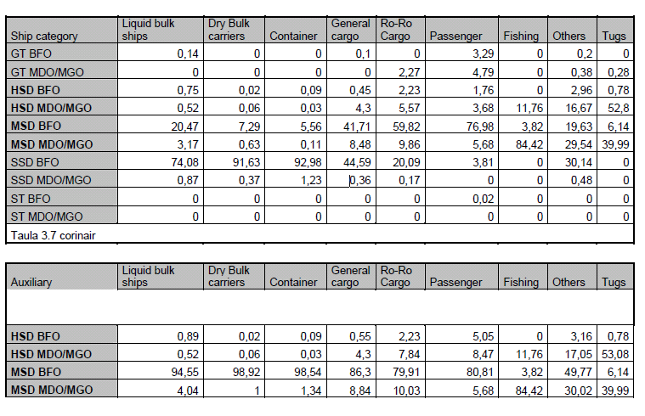

5. Emission factors used (Table 3.10 CORINAIR 2009, version June 2010):

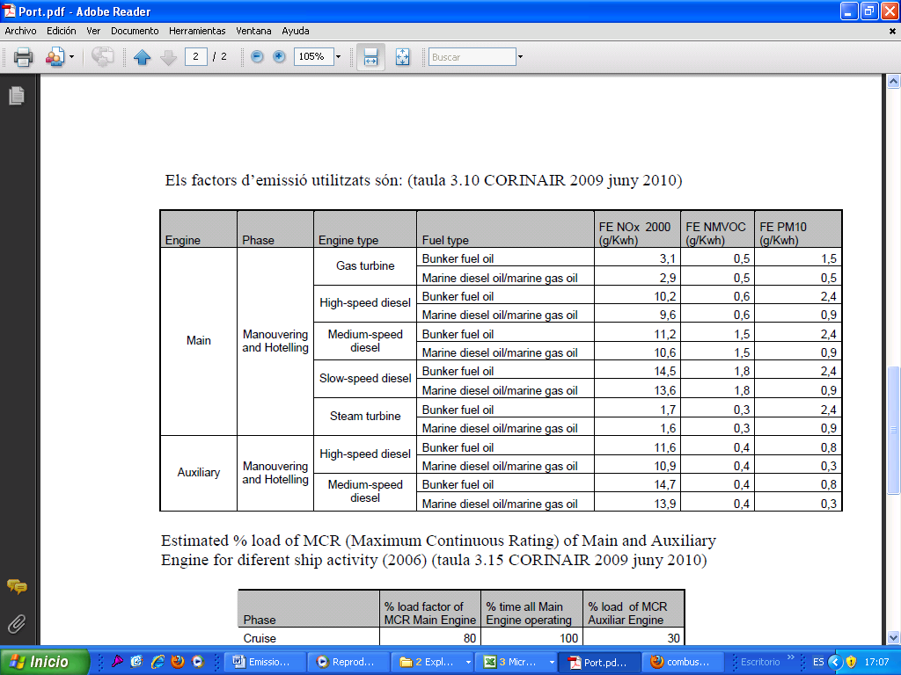

6. Estimated % load of MCR (Maximum Continuous Rating) of Main and Auxiliary Engine for different ship activity (2006) (Table 3.15 CORINAIR 2009, version June 2010).

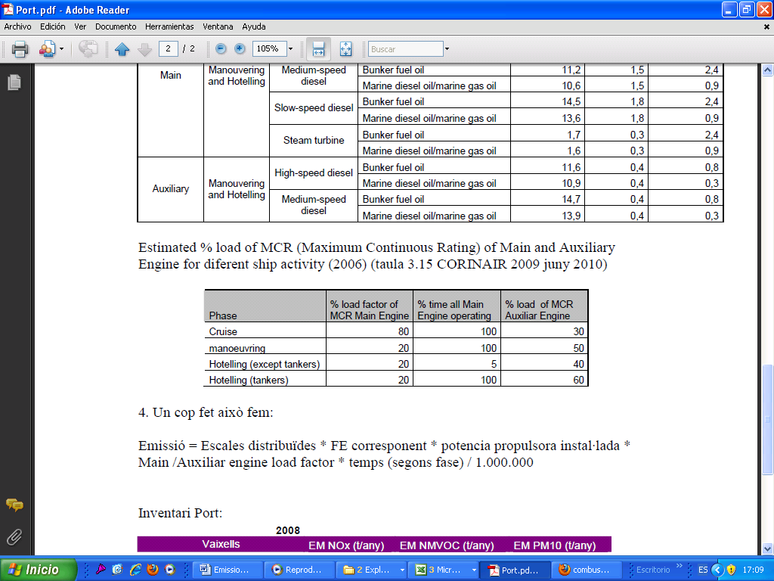

7. Emissions calculation:

Pollutant emission = Distributed stopovers * correspondent EF * installed propelling power * Main/Auxiliary engine load factor * time (according to phase) / 1.000.000

  - Anthropogenic Emission Inventory Results for Barcelona

The emission inventory results are presented in details in the Annex 1. Following, the most important emission sources are shown and the contribution of the maritime sector to the total emissions in Barcelona is identified.

For Barcelona, the three most important anthropogenic emission source sectors per pollutant are the following (results refer to a domain size of 100km x 100km with spatial resolution of 50km x 50km and reference year 2008) (Figure 1.1):

CO: 1) Industries (38.5%), 2) Central heating (27.1%) and 3) Road transport (26.8%).
NOx: 1) Road transport (41.0%), 2) Energy production (19.5%) and 3) Industries (16.6%).
SO2: 1) Non-road transport (without ship/harbor activities) (46.2%), 2) Energy production (27.9%) and 3) Industries (18.7%).
NH3: 1) Agriculture (92%), 2) Waste treatment and disposal (3.9%) and 3) Road transport (3%).
NMVOCs: 1) Solvent use (74.6%), 2) Road transport (6.3%) and 3) Waste treatment and disposal (4.9%).
PM10: 1) Road transport (27.6%), 2) Industries (20.3%) and 3) Agriculture (14.7%).
PM2.5: 1) Road transport (33.6%), 2) Non-road transport (without ship/harbor activities) (22.9%) and 3) Central heating (19.5%).

Focusing on the maritime sector (ship and harbor activities) being a key emission source sector within APICE, the percentage contribution for MNVOCs, PM10 and NOx (other pollutants have not been calculated yet for this sector): NMVOCs: 0.8%, PM10: 14%, NOx: 8.3%.

Figure 1.1. Anthropogenic source sectoral contribution to pollutant emissions in Barcelona.

Figure 1.1. (continuation)

- Genoa

  - Short Description of the Methodologies for the Estimation of Emissions for all Source Sectors except for the Maritime Sector

Local emission inventory for the Genoa area is own by Liguria Region and has been constructed by the sub-contractor Techne srl. Emissions due to diffuse sources have been calculated from statistical data referred to each municipality area for the activities described and then applying emission factors mainly extracted from the database developed by TECHNE srl in CORINAIR (further analysis have been made for the calculation of PM10 emission factors while TNO emission factors have been used for the estimation of heavy metals emissions). Statistical data for each activity are extracted from national and local data collection and lacks in the databases are filled by using proxy variables method.

Non-industrial combustion

Central heating: Fuel consumption due to domestic and commercial use has been distinguished and has been estimated separately for vegetal fuel, gas oil, G.P.L. and natural gas

Combustion in agriculture: For the estimation of fuel consumption in agriculture data has been provided directly by private companies

Industries (combustion)

Industrial combustion (boilers, turbines, engines): The fuel consumption relative to industrial point sources has been provided by factories, and then subtracted to the total consumption contained in national databases in order to obtain the emission of industrial diffuse sources emissions.

Industrial combustion (construction materials): Batch, drums and tunnel kiln production have been estimated by data provided by industrial cooperative and association.

Industries (production processes)

Asphalt roofing and road paving: Data from “Regional plan for extracting activities” have been used to calculate emissions relative to highways and regional roads, while costs of road maintenance evaluated from local budgets allowed for the calculation of emissions due to small roads.

Cement and glass production, mineral extraction from caves and rocks: Statistical data have been provided by Mineral and extracting activities Office and national distribution of employment in rock processing has been used for further refinement of data.
Extraction and distribution of fossil fuels & geothermal energy

Data on movement and stock of liquid fuels have been provided by Custom Office of Liguria Region while gas distribution companies have provided the total quantity of gas put into the Liguria Region network

Solvent and other product use

In order to estimate the emission related to solvent use the following activities have been considered: painting application (to car repairing, in construction sector, for ship constructions, in other industrial sectors and for domestic use), metal degreasing, dry cleaning, polyester processing, foam processing, chemicals processing, paint processing, glues processing, polyethylene processing, printing, oil extraction, car dewaxing, textile industries and shoe factories.

Road transport

SETS model has been used to calculate emission due to road transport. Local traffic has been distinguished from highway traffic and daily average vehicle fluxes have been considered for several vehicle categories. In some cases the slope of the road was available to get finer estimation of engine load. Monthly average temperatures have been extracted from a reference meteorological monitoring station.

Other mobile sources and machinery

Aviation: AIR model has been used. LTO (landing-takeoff) cycles for national and international traffic have been provided by local authority of Genoa airport and 9 different aircraft categories has been considered. Different emission factors have been used for each phase of LTOs.

Railways: Fuel consumption for movement and traction in all the Genoa stations has been used and a map of electrified and non-electrified route has been provided by Trenitalia spa.

Others: Fuel consumption for other mobile sources has been extracted from national and local data provided by local authorities and associations.

Waste treatment and disposal

Data of total compost production (in tons) have been provided by Environmental Protection Agency for Liguria Region (ARPAL).

Agriculture

Local data about agricultural activities were available from national statistics.

Natural emissions

Natural emissions over the simulation domain are calculate directly by the Physics Department of the Genoa University using the NEMO model (Natural Emission MOdel) which has been interfaced to the meteorological preprocessor WRF. For further details on the NEMO model, originally developed by the Laboratory of Atmospheric Physics of the Physics Department of the Aristotle University of Thessaloniki (Markakis et al. 2009; Poupkou et al. 2010).

  - Description of the Methodologies for the Estimation of Emissions for the Maritime Sector

Air Ships model, which is based on methodology developed on MEET project, has been used for the calculation of ship emissions contained in the Liguria Region inventory. With this code have been estimated for the Genoa harbor area the emission of following pollutants: CO, VOC, CO₂, NO_{x}, PM₁₀, SO_{x}, NH₃ and heavy metals.

The following formula gives the emissions of the above pollutants:

E_{i} = Σ_{jklm} E_{ijklm}

with

E_{ijklm} = S_{jkm}(T) . t_{jklm} . F_{ijlm}

Where
i pollutant
j fuel type
k vessel category
l engine type
m shipping phase
E_{i} total emissions for the i-th pollutant

E_{ijklm} emissions of i-th pollutant from use of j-th fuel on vessels of k-th category with l-type engines during m-th shipping phase
S_{jkm} (T) daily consumption of j-th fuel on vessels of k-th category during m-th shipping phase as a function of total tonnage T
t_{jklm} shipping days of vessels of k-th category with l-type engines during m-th shipping phase using th j-th fuel type
F_{ijlm} emission factor for i-th pollutant from use of j-th fuel in l-type engines during m-th shipping phase (average content of Sulfur in SO_{x} has been taken into account)
Here we report a list of the element considered in the above categories.

- Shipping phases:
- Cruising
- Maneuvering
- Hoteling
- Tank loading and unloading

- Vessel types:
- Bulk cargo
- Liquid cargo
- General cargo
- Container
- Passengers/Ro-Ro/Cargo
- High speed ferry
- Inland cargo

- Sail ships
- Tug
- Fishing
- Others

- Engine Types
- Boilers
- High speed engines
- Medium speed engines
- Low speed engines
- Gas turbines
- Touristic ships onboard motors
- Outboard motors
- Load and unload tanks engines

- Fuel types
- Heating oil
- Oil
- Diesel fuel
- Gasoline

  - Anthropogenic Emission Inventory Results for Genoa

For Genoa, the three most important anthropogenic emission source sectors per pollutant are the following (results refer to a domain size of 36km x 19km with spatial resolution of 1km x 1km and reference year 2005):

CO: 1) Road transport (77%), 2) Non-road transport (including ship/harbor activities) (18%) and 3) Central heating (3%).
NO_{x}: 1) Energy production (30%), 2) Non-road transport (including ship/harbor activities) (30%) and 3) Road transport (20%)..
SO₂: 1) Industries (85%), 2) Non-road transport (including ship/harbor activities) (7%) and 3) Combustion in manufacturing industry (5%).
NH₃: 1) Waste treatment and disposal (67%), 2) Road transport (21%) and 3) Agriculture (9%).
NMVOCs: 1) Road transport (41%), 2) Solvent use (29%) and 3) Extraction and distribution of fossil fuels and geothermal energy (13%).
PM₁₀: 1) Road transport (48%), 2) Non-road transport (including ship/harbor activities) (22%) and 3) Energy production (10%).
PM_{2.5}: 1) Road transport (52%), 2) Non-road transport (including ship/harbor activities) (23%) and 3) Central heating (10%).

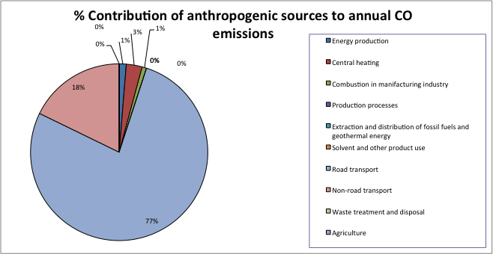

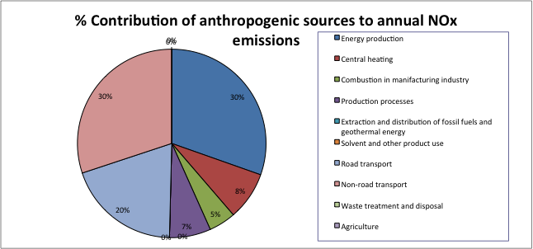

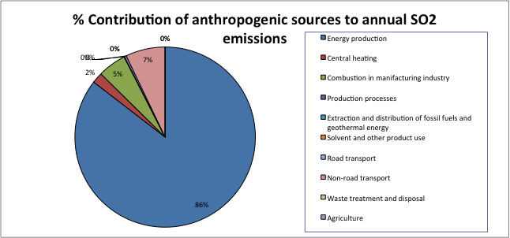
Figure 2.1 Anthropogenic source sectoral contribution to pollutant emissions in Genoa.

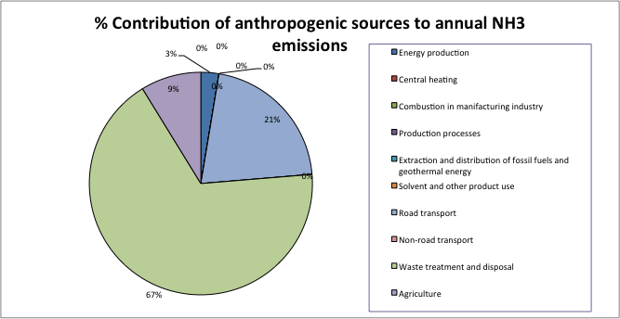
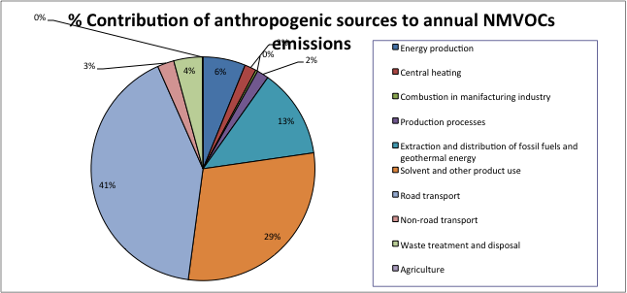
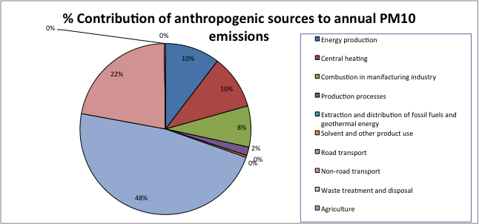
Figure 2.1 (continuation)

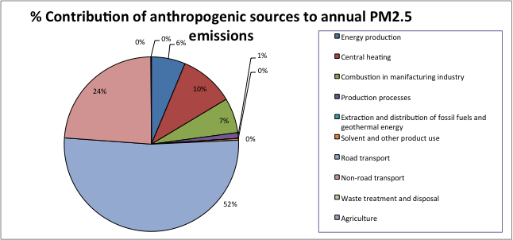
Figure 2.1 (continuation)

- Marseille

  - Short Description of the Methodologies for the Estimation of Emissions for all Source Sectors except for the Maritime Sector

The PACA emission inventory has been updated during 2010 for the reference year 2007. Emissions of 35 species (NO_{x}, SO₂, CO, TSP, PM₁₀, PM_{2.5}, NMVOC, CH₄, CO₂, N₂O, NH₃, heavy metals, HAP) for 80 anthropogenic activities are calculated over the PACA region area and sea with a kilometric spatial resolution. From annual emissions, disaggregating factors, according to activities and spatial location, are used at monthly, daily and hourly scales to reach an hourly temporal resolution. The Selected Nomenclature for Air Pollution (SNAP) at level 3 has been used with emission factors from several bibliographical resources.

Energy production

Emissions for this sector are directly issue from reports set up for the French general tax for polluting activities (TGAP). For missing emissions, annual energetic consummation and emission factors (EEA, 1999; CITEPA, 2002; CITEPA, 2004; EEA, 2004; CITEPA, 2008) are used for the calculation. All emissions of this sector are considered as point sources.

Central heating

Energetic consummations from annual report of the Regional Energy Observatory (ORE) are used as input data. For the residential sector, emissions are located according to population data as inhabitant density, accommodation area, fuel types and soil temperature issue from ALADIN meteorological model. Emissions for the tertiary sector are calculated for 8 activities: coffee-hotel-restaurant, community housing, health, education-research, sport, office, store, transport. Contribution of each activity is issue to CEREN (2001) and emissions are distributed according to employee number, bed number for hospital or student for school and university.

Industries

Emissions of main industrial sites are directly issued from a national database with also location of sources (e.g. stack, outlet, storage site) and their physical properties (e.g. height, diameter, emission speed, temperature). Emissions from industrial sites none included in this database are calculated using activity data and emission factors (EEA, 2007; CITEPA, 2008).

Extraction and distribution of fossil fuels & geothermal energy

Emissions from fuel distribution are connected with data issue from the national inventory of service stations (DRIRE, 2007), providing location and annual consumption, with population statistics and global annual fuel distribution data and emission factors from bibliography (OFEFP, 1995; EPA, 1998a; EPA, 1998b; Sambat et al. 2004). Emissions associated to extraction and loading of gaseous fossil fuels are

directly issued from the French annual declaration of polluting emissions and waste (GEREP) database. Natural gas consumption from other sectors (agriculture, industry, residential, tertiary) is connected with specific emission factor (CITEPA, 1999; OFEFP, 2000) to calculated emission from gas distribution networks.

Solvent and other product use

Connections between emission declarations, emission report from national survey, national inventory of factories, number of employees and emission factors by working place, are used to calculate emission from this sector associated to professional sector. For the domestic sector, estimations of emission factors by inhabitants are connected with population statistics.

Road transport

Emissions from road transport are calculated for cars, commercial vehicles 2-wheelers, trucks, urban busses and intra-urban busses from national statistics issue to CITEPA (2008) estimating fleet composition over PACA region and using the COPERT IV methodology (EEA, 2007) with some adaptation due to the great diversity of areas over PACA region (coastal areas with heavy population density, mountain areas). Engine emissions (hot emissions, cold-start, warning-up effects) and diffuse emissions (fuel evaporation, tyre wear) are considered in this methodology. Road traffic data are issue from several database sustained by national or local authorities, highway manager services or municipal services for the main town. Also, as PACA region is a great touristic destination, tourism effects have been considered in the emission calculation.

Other mobile sources and machinery

Emissions from railway transport correspond to rail network where diesel engines are in use. Database used is constituted by traffic data and by traffic type (high-speed train, freight, regional train). Traffic over 180km of regional fluvial network is issued from counting data at sluice gate. Emissions from activities on ground (takeoff, moving) and on air are calculated with main airport database. Both commercial and private flights are considered, except helicopter emissions. Emissions from agricultural as gardening vehicles are calculated from national and regional database.

Waste treatment and disposal

Average emission factors are derived from emissions data given by TGAP reports and are applied at the municipal and domestic waste treatment and disposal to calculate emissions for this sector. Also, emissions from open burning of agricultural waste are derived from departmental production data and using the CITEPA methodology (CITEPA, 2010). Emissions from cremation, sludge spreading and compost production are calculated using local data.

Agriculture

Emissions from agriculture sector are calculated with data from the last general agricultural inventory at the municipality scale, agricultural data at the regional scale and from annual agricultural statistics and using emission factors issue from EMEP/CORINAIR and IPCC methodology. Emissions are distributed over the area according to soil occupation from Corine Land Cover.

Natural emissions

Biogenic emissions are calculated from the MEGAN model (Guenther et al. 2006), implemented on CHIMERE model (Bessagnet et al. 2008). Input data are soil occupation from LANDSAT satellite images (CRIGE, 2004) with specific emission factors and meteorological data issue from WRF model at hourly and kilometric resolution to calculate biogenic VOC emissions.

  - Description of the Methodologies for the Estimation of Emissions for the Maritime Sector

To calculate the emissions for the maritime sector, the complete methodology MEET developed by Trozzi and Vaccaro (1998) is used with some adaptions due to specificities of study area. For this methodology, ship emissions are calculated as:

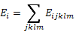

With

where: i for pollutant, j for fuel, k for ship class, l for engine ship class, m for phase and where E_{i} is the total emission of pollutant i, E_{ijklm} is the total emission of pollutant i from use of fuel j on ship class k with engines type l in mode m, S_{jkm}(GT) is the daily consumption of fuel j in ship class k in mode m as a function of gross tonnage, t_{jklm} is duration in day in navigation of ship of class k with engine type l using fuel j in mode m and F_{ijlm} is the average emission factor of pollutant i from fuel j in engines type l in mode m. The global approach used to calculate total maritime emissions is illustrated in the Error: Reference source not found Schematic illustration to the global approach used to calculate maritime emissions. (GPMM: Marseille Port Authority - Grand Port Maritime de Marseille).
Phases of ship traffic

This methodology is developed to estimate fuel consumption and emission during different phases of ship traffic represented as in Figure 3.2. For one stop inside a port, emissions from both two maneuvering and cruising phases (arrival and departure) and one hotelling phase have to be considered.
Error: Reference source not found. Schema of different phases for a ship movement between two ports (from Trozzi and Vaccaro, 1998).

Fuel consumption estimation

For each ship category, fuel consumption is calculated as function of gross tonnage when this information is available or as a default average consumption using the .

Table 3.1: Average consumption and consumption as function of gross tonnage at full power (Trozzi and Vaccaro, 1998).
Ship types | Average consumption (t/day) | Consumption at full power (t/day) as function of gross tonnage (GT)
Solid bulk | 33.80 | C_{jk} = 20.186 + 0.00049 * GT
Liquid bulk | 41.15 | C_{jk} = 14.685 + 0.00079 * GT
General cargo | 21.27 | C_{jk} = 9.8197 + 0.00143 * GT
Container | 65.88 | C_{jk} = 8.0552 + 0.00235 * GT
Passenger/Ro-Ro/ Cargo | 32.28 | C_{jk} = 12.834 + 0.00156 * GT
Passenger | 70.23 | C_{jk} = 16.904 + 0.00198 * GT
High speed ferry | 80.42 | C_{jk} = 39.483 + 0.00972 * GT
Inland cargo | 21.27 | C_{jk} = 9.8197 + 0.00143 * GT
Sail ships | 3.38 | C_{jk} = 0.4268 + 0.00100 * GT
Tugs | 14.35 | C_{jk} = 5.6511 + 0.01048 * GT
Fishing | 5.51 | C_{jk} = 1.9387 + 0.00448 * GT
Other ships | 26.40 | C_{jk} = 9.7126 + 0.00091 * GT
All ships | 32.78 | C_{jk} = 16.263 + 0.00100 * GT

As the fuel consumption is function of different mode, the daily consumption is calculated using the following equation:

where S_{jkm}(GT) is the daily consumption of fuel j in ship class k in mode m as a function of gross tonnage, Cjk(GT) is the daily consumption at full power of fuel j in ship class k as a function of gross tonnage and pm is fraction of maximum fuel consumption in mode m., and using the following .

Table 3.2: Fraction of maximum fuel consumption in different mode
(Trozzi and Vaccaro, 1998).
Mode | Fraction
Cruising | 0.80
Maneuvering | 0.40
Hotelling default | 0.20
Hotelling passenger | 0.32
Hotelling tanker | 0.20
Hotelling other | 0.12
Tug ship assistance | 0.20
Tug moderate activity | 0.50
Tug under tow | 0.80

Emission factors

With MEET methodology, emission factors are associated to engine types and refer to fuel consummation. In the following tables (Table 3.3, , Table 3 5.5) different emission factors are shown. Relations between ship types and engine types are not given by MEET methodology and the relation used is presented in Table 3.8.

Table 3.3: Emission factors for cruising mode (kg/ton of fuel)
(Trozzi and Vaccaro, 1998).
Engine types | NOx | CO | CO2 | VOC | PM | SOx
Steam turbines – BFO engines | 6.98 | 0.431 | 3200 | 0.085 | 2.50 | 20s
Steam turbines – MDO engines | 6.25 | 0.6 | 3200 | 0.5 | 2.08 | 20s
High speed diesel engines | 70 | 9 | 3200 | 3 | 1.5 | 20s
Medium speed diesel engines | 57 | 7.4 | 3200 | 2.4 | 1.2 | 20s
Slow speed diesel engines | 87 | 7.4 | 3200 | 2.4 | 1.2 | 20s
Gas turbines | 16 | 0.5 | 3200 | 0.2 | 1.1 | 20s
Inboard eng. pleasure craft – diesel | 48 | 20 | 3200 | 26 | neg. | 20s
Inboard eng. pleasure craft – gasoline | 21.2 | 201 | 3200 | 13.9 | neg. | 20s
Outboard engines - gasoline | 1.07 | 540 | 3000 | 176 | neg. | 20s

Table 3.4: Emission factors for maneuvering mode (kg/ton of fuel)
(Trozzi and Vaccaro, 1998).
Engine types | NOx | CO | CO2 | VOC | PM | SOx
Steam turbines – BFO engines | 6.11 | 0.19 | 3200 | 0.85 | 2.50 | 20s
Steam turbines – MDO engines | 5.47 | 0.27 | 3200 | 5.0 | 2.08 | 20s
High speed diesel engines | 63 | 34 | 3200 | 4.5 | 1.5 | 20s
Medium speed diesel engines | 51 | 28 | 3200 | 3.6 | 1.2 | 20s
Slow speed diesel engines | 78 | 28 | 3200 | 3.6 | 1.2 | 20s
Gas turbines | 14 | 1.9 | 3200 | 0.3 | 1.1 | 20s
Inboard eng. pleasure craft – diesel | 48 | 20 | 3200 | 26 | neg. | 20s
Inboard eng. pleasure craft – gasoline | 21.2 | 201 | 3200 | 13.9 | neg. | 20s
Outboard engines - gasoline | 1.07 | 540 | 3000 | 176 | neg. | 20s

Table 3 5: Emission factors for hotelling mode (kg/ton of fuel)
(Trozzi and Vaccaro, 1998).
Engine types | NOx | CO | CO2 | VOC | PM | SOx
Steam turbines – BFO engines | 4.55 | 0 | 3200 | 0.4 | 1.25 | 20s
Steam turbines – MDO engines | 3.11 | 0.6 | 3200 | 0.5 | 2.11 | 20s
High speed diesel engines | 28 | 120 | 3200 | 28.9 | 1.5 | 20s
Medium speed diesel engines | 23 | 99 | 3200 | 23.1 | 1.2 | 20s
Slow speed diesel engines | 35 | 99 | 3200 | 23.1 | 1.2 | 20s
Gas turbines | 6 | 7 | 3200 | 1.9 | 1.1 | 20s
Inboard eng. pleasure craft – diesel | neg. | neg. | neg. | neg. | neg. | neg.
Inboard eng. pleasure craft – gasoline | neg. | neg. | neg. | neg. | neg. | neg.
Outboard engines - gasoline | neg. | neg. | neg. | neg. | neg. | neg.

Emission factors of PM10, PM2.5, NMVOC and CH4 are calculated using the following relations issued from EEA (2006) and applied for all modes:

, , , and

Table 3.6: Emission factors for remaining pollutants (EEA, 2006).
Fuel type | PCDDF | Pb | Cd | As | Ni | Hg | Cr | Cu | Se | V | Zn | PAH_{t}
Distillate | 4 E-06 | 0.1 | 0.01 | 0.05 | 0.07 | 0.05 | 0.04 | 0.05 | 0.2 |  | 0.5 | 2
Residual | 4 E-06 | 0.2 | 0.03 | 0.5 | 30 | 0.02 | 0.2 | 0.5 | 0.4 |  | 0.9 | 2

Navigation duration

The navigation duration is calculated using the average cruise speed for each ship type () and the distance covered over the study area. The manoeuvring duration is calculated from the same table reducing the average speed by half.

Table 3.7: Average speed for ship type (Trozzi and Vaccaro, 1998).
Ship types | Average speed (knots)
Solid bulk | 14.32
Liquid bulk | 14.20
General cargo | 14.29
Container | 19.09
Passenger / Ro-Ro / Cargo | 16.49
Passenger | 17.81
High speed ferry | 36.64
Inland cargo | 14.29
Sail ships | 9.63
Tugs | 12.91
Fishing | 11.96
Other ships | 13.45
All ships | 14.77

Input data

Input data required to calculate emissions from maritime transport are obtained from Marseille-Fos port authority (GPMM) by means of a traffic database given ship types, gross tonnage, stop duration, quay location, origin and destination port for every ships calling at Marseille-Fos port during 2007. Tug activities are given as a yearly data. Manoeuvring mode is associated to the moment where ships entrance into port area. At this moment, ships have to reduce speed and to follow specific ways to approach quays. These data are reported as input data. Tugs activities are associated to this mode. For the cruising phase, trajectories are plotted using data from Automatic Information System (AIS), given ship position in real time and are validated by harbor master’s office. Plan of major maritime roads, manoeuvring phases and tug movements are shown in the Figure 3.1.

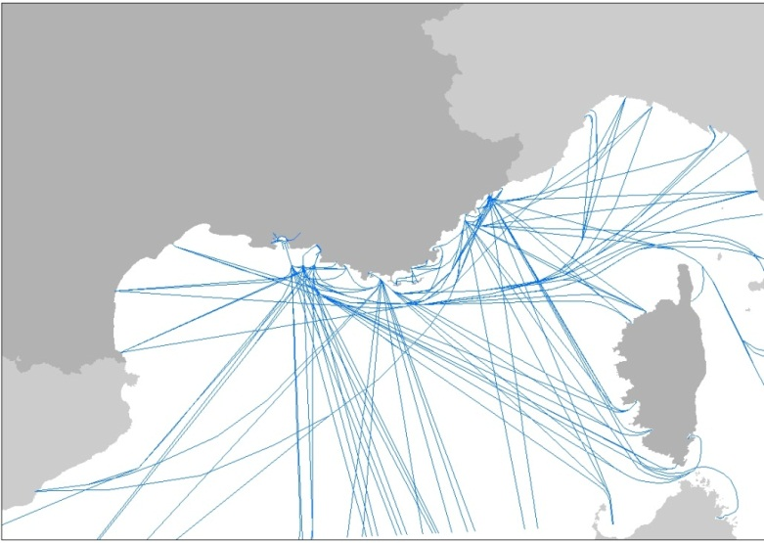
Figure 3.1: Ship trajectories associated to a departure or an arrival in a port of PACA region.

The relation used between ship types and engine types is given in the following table X and is issue from several discussions with harbour master’s office.

Table 3.8: Correspondence between ship and engine types.
Ship types | Engine types | Ship types | Engine types
Solid bulk | Slow speed diesel | Inland cargo | Slow speed diesel
Liquid bulk | Slow speed diesel | Sail ships | Medium speed diesel
General cargo | Medium speed diesel | Tugs | Medium speed diesel
Container | Slow speed diesel | Fishing | Medium speed diesel
Passenger/Ro-Ro/Cargo | Medium speed diesel | Other ships | Medium speed diesel
Passenger | Medium speed diesel | All ships | Medium speed diesel
High speed ferry | High speed diesel

  - Anthropogenic Emission Inventory Results for Marseille

The emission inventory results are presented in details in the Annex 4. Following, the most important emission sources are shown and the contribution of the maritime sector to the total emissions in Marseille is identified. Results of this part refer to the area shown in the (100km x 100km) and to reference year 2007.

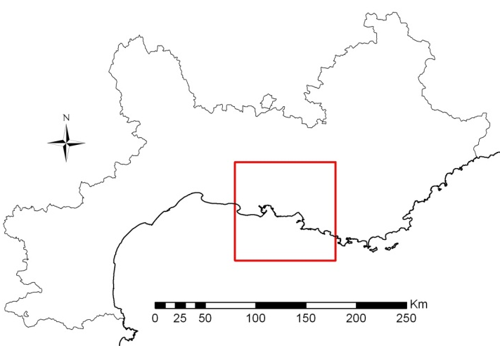

Figure 3.2: Study area (100km x 100km, resolution 1km x 1km) where emissions inventory is extracted.
For Marseille, the three most important anthropogenic emission source sectors per pollutant are (see also Error: Reference source not found).

CO: 1) Industries (68%), 2) Road transport (13%) and 3) Ship/harbor activities (6%).
NO_{x}: 1) Road transport (34%), 2) Industries (23%) and 3) Energy production (20%).
SO₂: 1) Industries (38%), 2) Energy production (35%) and 3) Ship/harbor activities (20%).
NH₃: 1) Waste treatment and disposal (61%), 2) Agriculture (28%) and 3) Road transport (8%).
NMVOCs: 1) Industries (25%), 2) Solvent use (23%) and 3) Road transport (17%).
PM₁₀: 1) Industries (35%), 2) Road transport (29%) and 3) Central heating (13%).
PM_{2.5}: 1) Road transport (32%), 2) Industries (27%) and 3) Central heating (18%).

Focusing on the maritime sector (ship and harbour activities) being a key emission source sector within APICE, the percentage contribution to total anthropogenic emissions is 5.9% for CO, 16.6% for NOx, 20.2% for SOx, 9.4% for NMVOCs, 3.6% for PM10 and 5.3% for PM2.5.
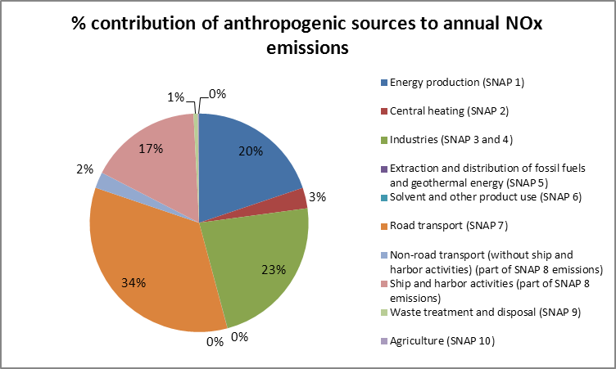

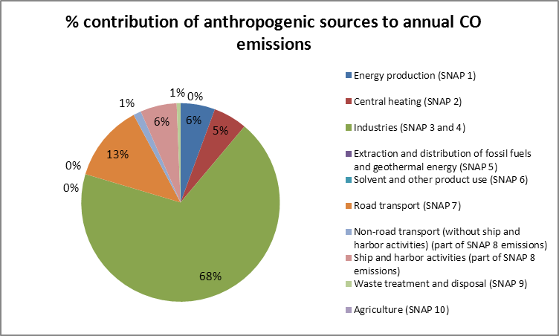

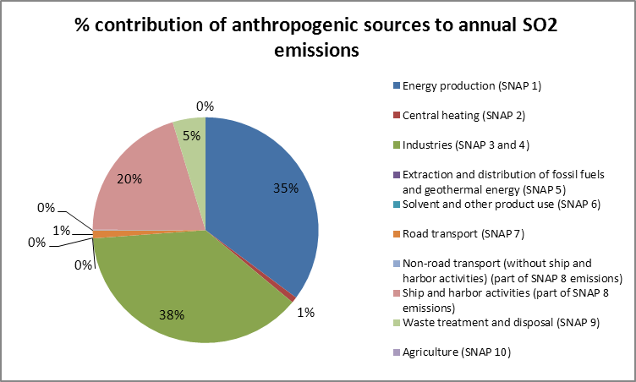
Figure 3.5. Anthropogenic source sectoral contribution to pollutant emissions in Marseille.
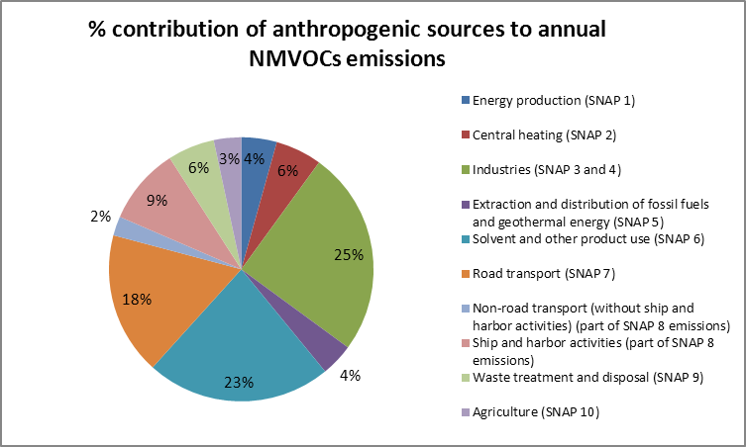

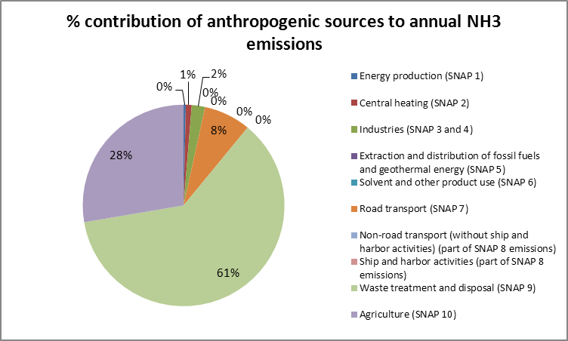

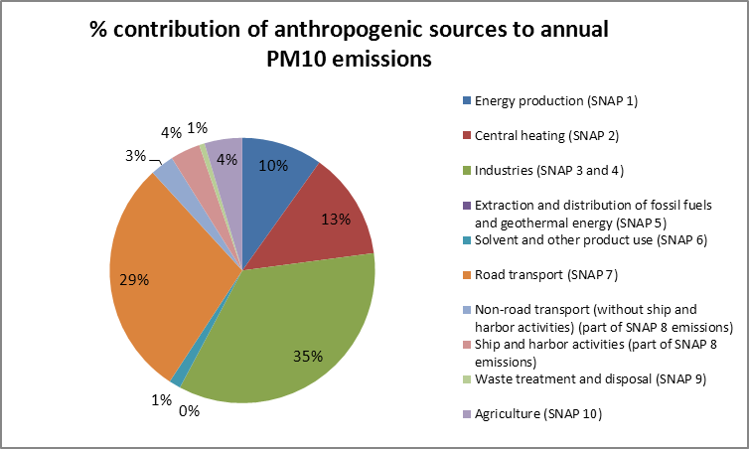
Figure 3.5. (continuation)

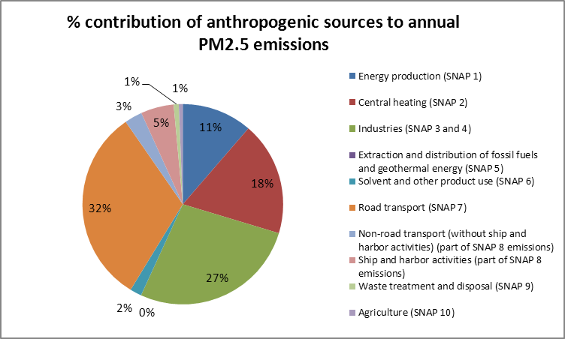
Figure 3.5. (continuation)

- Thessaloniki

  - Short Description of the Methodologies for the Estimation of Emissions for all Source Sectors except for the Maritime Sector

The emission inventory for the greater Thessaloniki area includes 28 different anthropogenic activities, the emissions of which were either derived from existing national emission databases (e.g. for the industrial sector) and international emission databases (e.g. the distribution of fossil fuels sector emissions were taken from The Netherlands Organization (TNO) database (Visschedijk et al. 2007) or quantified using mainly the methodologies and emission factors of the EMEP/CORINAIR emission inventory handbook (EEA, 2006). The following list describes the basic statistical quantities and emission factors which were used for the determination of the pollutant emission fluxes for the anthropogenic activities for which activity information were available and as a result the calculation of emissions was possible. Emissions have been quantified using the anthropogenic emission model MOSESS (MOdel for the Spatial and tEmporal diStribution of emissionS) that has been developed by the Laboratory of Atmospheric Physics of the Physics Department of the Aristotle University of Thessaloniki (Markakis et al. 2011). The emission inventory is representative for 2008 and adjustment years.

Central heating

The annual consumed quantities of wood, oil and gas fuels were used. The emission factors were differentiated to account for the combustion type e.g. fireplaces/stoves, single house boilers and medium size boilers.

Solvent and other product use

Glues and adhesives, domestic use of solvents: Population statistics multiplied with per capita emission factors.

Painting applications: The annual consumed quantities of paint in 4 different painting activities were used. Emission factors correspond to the emission of pollutant per mass of paint used. For wood coating operations the total area of wood coated in annual basis was used (emission factors are given per unit area coated). For vehicle painting the total area of small, medium and large cars was used. Emission factors correspond to the emission of pollutant per unit area of the painted cars.

Metal degreasing: The annual consumed quantities of solvent were used. Emission factors correspond to the emission of pollutant per mass of solvent used in the metal degreasing units.

Dry cleaning: The annual mass quantities of material cleaned in the dry cleaning units were used. Emission factors were differentiated to account for the cleaning machinery/method used and they correspond to the emission of pollutant per mass of material cleaned.

Foam processing: The annual consumed quantities of EPS blowing agent were used. Emission factors correspond to the emission of pollutant per mass of agent used in the foam processing units.

Printing: The annual quantities of ink consumed in 5 different activities of the printing industry were used. Emission factors were differentiated to account for the printing technique implemented and they correspond to the emission of pollutant per mass of ink consumed.

Oil extraction: The annual quantities of oil seeds processed were used. Emission factors correspond to the emission of pollutant per mass of oil seeds used.

Car dewaxing: The number of cars dewaxed after storage/transport was used. Emission factors correspond to the emission of pollutant per car dewaxed.

Wood preservation: The annual quantities of wood preserved were used. Emission factors correspond to the emission of pollutant per mass of wood preserved.

Road transport

The emissions were calculated using the annual registered fleet of cars, trucks, busses and 2-wheelers in the area. The annual mileage driven for those vehicles per driving mode, engine type and technology as well as the circulating speed per driving mode were also available (emission factors were calculated from those speed values). Emissions for the non-exhaust part as well as the evaporative emissions of NMVOCs were also calculated using the same statistics.

Other mobile sources and machinery

Aviation: The annual quantities of jet-fuel for domestic and international flights and the LTOs per aircraft type were used. Emission factors correspond to the emission of pollutant per mass of fuel consumed. Emissions for LTO operations and the cruising mode of aircrafts were determined.

Agricultural/industrial/forestry/household machineries, railway transport: The registered fleet of machinery/vehicles per fuel type (gasoline or diesel) was used. The split in engine technology, engine power output and the annual hours of operation was also available. Emission factors correspond to the emission of pollutant per KWh of engine power output.

Waste treatment and disposal

Municipal waste, agricultural waste: The annual quantities of waste processed/burned were used. Emission factors correspond to the emission of pollutant per mass of waste processed/burned.

Agriculture

Manure management, grazing: The numbers of 7 different animal types were used. Emission factors correspond to the emission of pollutant per animal.

Animal husbandry: The numbers of 5 different animal types and the proportion of annual time that the animals spend in housing environment were used. Emission factors correspond to the emission of pollutant per animal.

Fertilizer application: The annual quantities of 10 different fertilizer types were used. Emission factors correspond to the emission of pollutant per mass of fertilizer used.

Legumes cultivation: The area of legumes cultivation was used. Emission factors correspond to the emission of pollutant per unit area of cultivation.

Natural emissions

The emissions originating from natural sources were calculated with the use of the emission model namely NEMO (Natural Emission MOdel) that has been developed by the Laboratory of Atmospheric Physics of the Physics Department of the Aristotle University of Thessaloniki (Markakis et al. 2009). Wind erosion dust, sea salt and

biogenic NMVOCs emissions can be calculated using the WRF model meteorology. The methodology of the NATAIR project (NATAIR, 2007) is implemented for the calculation of wind erosion dust emissions employing the high resolution landcover database of USGS and the soil texture maps compiled specifically for this purpose (Webb et al. 2000). Sea salt emissions are calculated based on the formula of Sofiev et al. 2011. The methodology described in Poupkou et al. (2010) is implemented for the calculation of biogenic isoprene, monoterpenes and other VOCs biogenic emissions.

  - Description of the Methodologies for the Estimation of Emissions for the Maritime Sector

For the estimation of emissions of the maritime sector the methodology of EEA (2006) was primarily used. A number of emission factors of from Cooper and Gustafsson (2004) were implemented. The methodology of Martin et al. (2007) was used for the determination of emissions originating from the harbor operations.

Inland waterways vessels

To calculate the emissions the following equation was used:

E_{i,j} = F_{j} * HP_{j} * HRS_{j} * LF_{j} * EF_{i,j} * DF_{j}

where: E is the emission of the pollutant i and engine horsepower j, F is the registered fleet of vessels per horsepower class j, HP is the representative horsepower of the class j (in KW), HRS is the annual hours of operation of the vessel of horsepower j (in hours) and LF is the loading factor of the vessel of horsepower j (dimensionless). The emissions factor (EF_{j}) corresponds to the emission of pollutant i per KWh of horsepower of class j. Finally the DF_{i} is the age degradation factor which is calculated from a representative age value (in years) of each vessel of horsepower j.

Fish catching ships

To calculate the emissions the following equation was used:

E_{i} = F * C * T * EF_{i}

Where: E is the emission of the pollutant i, F is the registered fleet of vessels, T is the annual operating time of the vessel (in days). The emissions factor (EF_{i}) corresponds to the emission of pollutant i per mass of consumed fuel. The consumption of fuel is calculated from the provided gross tonnage of the vessels based on the relevant equations of the EMEP/CORINAIR handbook for fish catching ships (EEA, 2006).

Passenger ships

To calculate the emissions the following equation was used:

E_{i} = F * C * (D/SPD) * EF_{i}

Where: E is the emission of the pollutant i, F is the registered fleet of vessels, SPD is the representative speed of the vessel (in knots) and D is the distance cruised (in Km). The emissions factor (EF_{i}) corresponds to the emission of pollutant i per mass of consumed fuel. The consumption of fuel is calculated from the provided gross tonnage of the vessels based on the relevant equations of the EMEP/CORINAIR handbook for passenger ships (EEA, 2006).

Tugs

To calculate the emissions the following equation was used:

E_{i} = F * C * (D/SPD) * EF_{i}

Where: E is the emission of the pollutant i, F is the registered fleet of vessels, SPD is the representative speed of the vessel (in knots) and D is the distance cruised (in Km). The emissions factor (EF_{i}) corresponds to the emission of pollutant i per mass of consumed fuel. The consumption of fuel is calculated from the provided gross tonnage of the vessels based on the relevant equations of the EMEP/CORINAIR handbook for passenger ships (EEA, 2006).

Cargo shipping

To calculate the emissions 2 different methodologies were used. For the determination of PM and NH3 the following equation was used:

E_{i,j} = F_{j} * C_{j} * (D/SPD_{j}) * ET * EF_{i,j}

Where: E is the emission of the pollutant i of vessel type j, F is the registered fleet of vessel type j, SPD is the representative speed of the vessel type j (in knots) and D is the distance cruised (in Km). The emission factor (EF_{i,j}) corresponds to the emission of pollutant i per mass of consumed fuel of vessel type j. The consumption of fuel is calculated from the provided gross tonnage of the vessels based on the relevant equations of the EMEP/CORINAIR handbook for cargo ships (EEA, 2006). ET is the proportion of the fleet equipped with slow or medium speed engine.

For the remaining pollutants the equation used was:

E_{i,j} = F_{j} * (D/SPD_{j}) * ET * EF_{i.j}

Where: E is the emission of the pollutant i of vessel type j, F is the registered fleet of vessel type j, SPD is the representative speed of the vessel type j (in knots) and D is the distance cruised (in Km). The emissions factor (EF_{j,j}) is expressed in mass of pollutant i per operating time and it is calculated from relevant equations which include the engine power output of the vessel type j and the number of engines. ET is the proportion of the fleet equipped with slow or medium speed engine.

Harbor operations

To calculate the emissions the following equation was used (Martin et al. 2007):

E_{i,j} = Q * EF_{i,j}

Where: E is the emission of particles of material i handled in operation j (loading/unloading/storage) and Q is the quantities of material i in each operation j. The emission factor (EF_{j,j}) is expressed in mass of pollutant per mass of material i handled in operation j and it is a function of the relative humidity of the material i.

  - Anthropogenic Emission Inventory Results for Thessaloniki

For Thessaloniki, the three most important anthropogenic emission source sectors per pollutant are the following (results refer to a domain size of 100km x 100km with spatial resolution of 2km x 2km and reference year 2008):

CO: 1) Road transport (67%), 2) Central heating (15.1%) and 3) Non-road transport (without ship/harbor activities) (10.6%)
NOx: 1) Road transport (36%), 2) Non-road transport (without ship/harbor activities) (32.6%) , and 3) Ship/Harbor activities (22.9%).
SO2: 1) Industries (63.5%), 2) Ship/Harbor activities (27.2%) and 3) Extraction and distribution of fossil fuels and geothermal energy (8.8%).
NH3: 1) Agriculture (80.1%), 2) Road transport (16.5%) and 3) Waste treatment and disposal (2.5%).
NMVOCs: 1) Solvent use (36.2%), 2) Road transport (26.8%) and 3) Extraction and distribution of fossil fuels and geothermal energy (16.4%).
PM10: 1) Industries (55.7%), 2) Central heating (12.1%) and 3) Non-road transport (without ship/harbor activities) (10.3%).
PM2.5: 1) Industries (49.3%), 2) Central heating (16.3%) and 3) Non-road transport (without ship/harbor activities) (13.2%).

Focusing on the maritime sector (ship and harbor activities) being a key emission source sector within APICE, the percentage contribution to total anthropogenic emissions is 1.5% for CO, 22.9% for NOx, 27.2% for SOx, 0.6% for NMVOCs, 2.1% for PM10 and 2.7% for PM2.5.

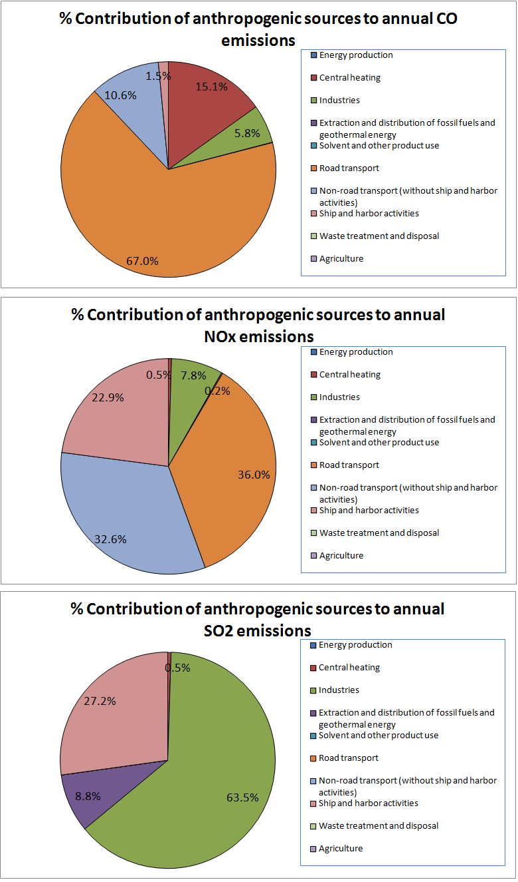
Figure 4.1. Anthropogenic source sectoral contribution to pollutant emissions in Thessaloniki

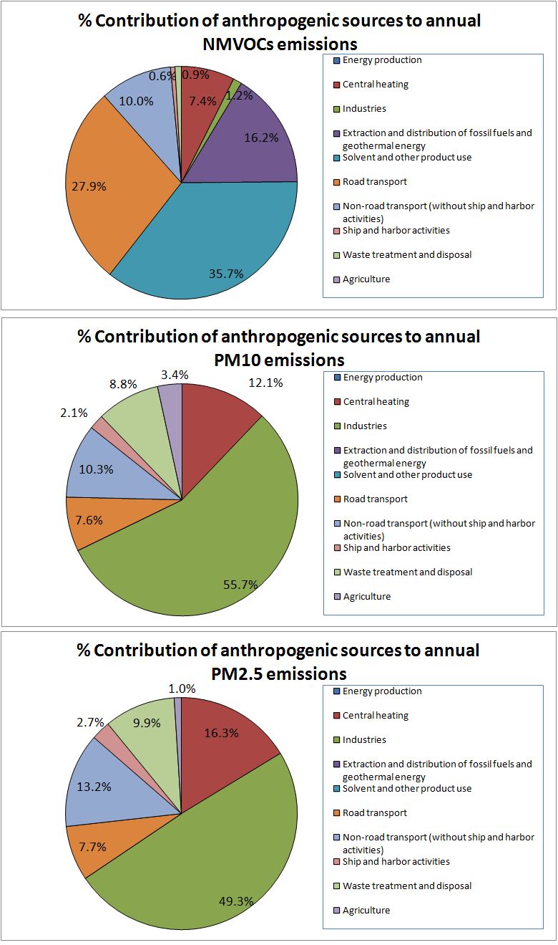
Figure 4.1. (continuation)
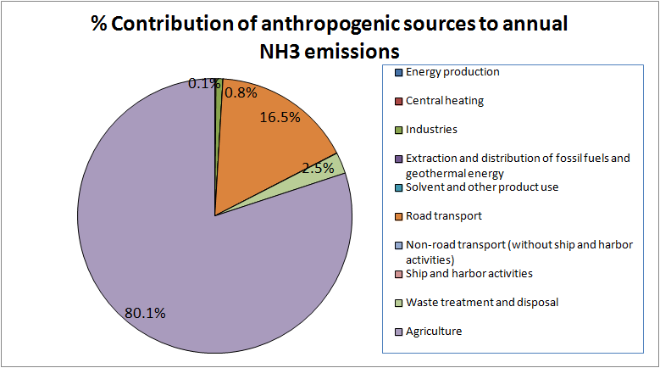
Figure 4.1. (continuation)

- Venice

  - Short Description of the Methodologies for the Estimation of Emissions for all Source Sectors except for the Maritime Sector

The Veneto Region emission inventory is based on INEMAR (INventario di EMissioni in ARia - Air Emission Inventory) which is a database developed by a consortium of Italian Regions leaded by the Lombardy Region (Caserini et al. 2002; Caserini et al. 2005). It is partially established using a bottom-up approach (industrial point sources, airports and harbors), and partially based on activity indicators and emission factors. The level of resolution of the data is the municipality and the emissions are available by SNAP activity and fuel. INEMAR is mostly based on the CORINAIR methodology. The emission factors used are frequently taken from the CORINAIR Guidebook; however when specific surveys are available at local level the latter are preferred. PM10 and PM2.5 emissions are derived by granulometric distribution at SNAP activity from TSP emissions. A short description of the estimation methodology applied to the 11 CORINAIR SNAP Sectors is presented in the following paragraphs. A more detailed description of methodology and emission factor used for ships and harbour activities is presented in a specific paragraph below.

Energy production

This sector is completely covered by point sources, for which emission data are given as stack emission measurements performed by ARPAV and/or by IPPC emission permits.

Central heating

These are area source emissions estimated using emission factors based on residential fuel consumptions. Data related to fossil fuels are provided by the Italian ministry of economic development as statistical reports on natural gas distributed and sales of gas oil, fuel oil and LPG at provincial level. For wood consumption has been used the results of a survey at regional level commissioned by ISPRA/ARPA Lombardy.

Industries

Emissions for these sectors are considered partially as point sources (in analogy to Sector 1) and partially as area sources estimated from emission factors. For the Sector 3 when measures aren’t available, fuel consumption indicators are used, whereas for Sector 4 the emission factors principally used are based on throughput indicators.

Extraction and distribution of fossil fuels & geothermal energy

This sector is completely estimated as area sources, using different activity indicators, mainly regarding the losses from the natural gas distribution network and from the evaporative emissions by petrol stations.

Solvent and other product use

Also this sector is treated as area sources, and the emission factors are connected with the consumption of solvents. The reconstruction of this amount at local level is derived from the national total of solvents produced in reference year downloadable from the EUROSTAT Prodcom statistics. It is obtained as budget among production, import and export of paints and other products containing solvents. This consumption is downscaled using the ratio between the number of employees, at local and national level, taking into account only the SNAP activities connected to use of solvents.

Road transport

This is the only Sector not estimated by INEMAR but following a top-down approach by distributing at local level national emissions by means of surrogated spatial datasets (population, car fleet characterization, road network design).

Other mobile sources and machinery

This sector comprehends harbors, airports and off road transport emissions. The methodology used for harbor emissions is described below in more detail. For airports the detailed methodology of CORINAIR Guidebook has been followed starting from the aircraft traffic data for the three major Veneto Region airports (among them Venice airport). The off-road emissions are calculated from fuel consumption of machines in agriculture and forestry and trains diesel fuelled; the statistics of consumptions have been collected from the Regional Agency for Agricultural Payments (AVEPA) and Trenitalia (the Italian railway company).

Waste treatment and disposal

The emissions are derived in a bottom up approach starting from a census of landfills and incinerators (some of which are treated as point sources with measured data). Landfills emissions are relevant mainly for GHGs.

Agriculture

This sector is relevant mainly for ammonia emissions; for this pollutant the most important contribution comes from animal husbandry and manure management. The emission factors for this subsector (10.09) are taken from EMEP/CORINAIR and IPCC methodology customized on the Italian reality of animal husbandry. Regarding the agriculture, the emissions from cultures with fertilisers are estimated using the national statistical institute (ISTAT) on utilised agricultural area (hectares) and the amount of fertilisers annually used. This estimation complies with EMEP/CORINAIR too. PM10 emissions coming from animal husbandry are based on the RAINS project (IIASA, 2001) and on a study carried out by the University of Milan.

Natural emissions

In INEMAR this sector comprehends biogenic NMVOC and GHGs emissions, and other natural minor relevant emission activities (wild fire, pyrotechnics and smoke). For the APICE project purposes the natural emissions, other than the INEMAR estimations, specific processors for the estimation of sea-salt and windblown dust have been implemented. The methodologies used for the biogenic emissions considered are:

- NMVOC from forests and crops: the method implemented in INEMAR estimates the emissions of isoprene, monoterpenes and other VOC (sequiterpenes and oxygenated VOC), basing on the emission factors and the algorithms described in Karl et al. (2009) which starts from EMEP/CORINAIR methodology.
- Sea salt: the processor used implement the methodology described in Gong (2003) and Monahan et al. (1986). This is the same methodology used in the NATAIR project (NATAIR, 2007) and described in the final report.
- Windblown dust: the processor had been build following the NATAIR project methodology.

  - Description of the Methodologies for the Estimation of Emissions for the Maritime Sector

Harbour emissions for the Venetian study area takes account of both the huge Venice harbour and the smallest harbour of the near city of Chioggia. For both the harbours, pollutant emissions are estimated only for shipping activities, whereas, since a lack of detailed activity data required, other harbour emissions (freight loading and unloading, handling equipment) are not considered. The shipping activities emissions are referred for both Venice and Chioggia harbors to the calendar year 2008.

The two estimates were built up slightly differently due to a dissimilar availability of data activities provided by the two different Port Authorities. As for the Venice harbor, shipping emissions derive by a bottom up estimation conducted by ARPAV-DAP VE in 2007 (ARPAV, 2007) and related to year 2005. Ship movements during the whole year 2005 were supplied by Venice Port Authority, as well as the classification of every single ship on a restricted number of typologies. This classification allowed to apply a derived MEET methodology (Trozzi and Vaccaro, 1998) for ship emissions quantification starting from restrict number emissions factors for ship typologies and operational phases such as cruising, hotelling, maneuvering (EC, 2002).

Within APICE implementation, the 2005 bottom up estimation has been updated using the ship movements’ 2008 to 2005 ratio as coefficient of variation (APV, 2010; APV, 2011). For Chioggia harbor, shipping emissions have been directly calculated applying the derived MEET methodology (Trozzi and Vaccaro, 1998) using ship movements referring to calendar year 2008. Following a more detailed description of the algorithms applied, derived from the MEET methodology but using Emission Factors by European Commission (EC, 2002).

In the detailed MEET methodology (Trozzi and Vaccaro, 1998, chapter 3), the ships emissions are obtained as:

with:

i | pollutant (NOx, SOx, CO, VOC, PM, CO2);
j | fuel (Bunker fuel oil, Marine diesel oil, Marine gas oil, Gasoline fuel);
k | ship class for use in consumption classification (Solid Bulk, Liquid Bulk, General Cargo, Container, Passenger/Ro-Ro/Cargo, Passenger, High speed ferries, Inland Cargo, Sail ships, Tugs, Fishing, Other);
l | engines type class for use in emission factors characterization (Steam turbines, High speed motor engines, Medium speed motor engines, Slow speed motor engines, Inboard engines, Outboard engines, Tanker loading and offloading);
m | Operating mode (Cruising, Maneuvering, Hotelling, Tanker offloading, Auxiliary generators);
Ei | total emissions of pollutant I;
E_{ijklm} | total emissions of pollutant i from use of fuel j on ship class k with engines type l in mode m;
S_{jkm}(GT) | daily consumption of fuel j in ship class k in mode m as a function of gross tonnage (GT);
t_{jklm} | days operating of ships of class k with engines type l using fuel j in mode m;
F_{ijlm} | average emission factors of pollutant i from fuel j in engines type l in mode m (for SOx, taking into account average sulfur content of fuel).

And where the daily consumption of fuel is calculated as:

with:

C_{jk} (GT) | daily consumption at full power of fuel j in ship class k as a function of gross tonnage (GT);
p_{m} | fraction of maximum fuel consumption in mode m (Table 5.1)  Table 5.1. Fraction of maximum fuel consumption in different mode (Trozzi and Vaccaro, 1998)

For the daily consumption of fuel at full power C_{jk} functions are listed in the MEET Report with the generic formula:

$$C_{j,k}=a_{j,k}+b_{j,k}⋅\text{GT}$$

with a and b empirical coefficients explicitly listed in the MEET Report.

Starting from the ship movement databases provided by the Port Authorities, reporting the name of every ship entering the harbor during the year as well as the hour and the day of its arrival and departure, its gross tonnage and typology, the fuel consumptions were estimated.

Since in the ship movement databases there was no data on fuel type and engine type, for the calculation of total emission rather than the above equations and the MEET Emission Factors depending on fuel, the simpler following equation was used:

$$E_{\text{ikm}}=S_{\text{km}}(\text{GT})⋅t_{\text{km}}⋅F_{\text{ikm}}$$

Where average emission factors F_{ikm} of pollutant i in ship class k and in mode m don’t depend on fuel typology and engine type.

The necessary Emission Factors without the dependency on fuel were found in the study conducted by Entec UK Ltd on behalf of the European Commission: “Quantification of emissions from ships associated with ship movements between ports in the European Community” (EC, 2002). Since the European Commission document doesn’t report any emission factor for CO, for this pollutant was used the value reported in EMEP/CORINAIR Emission Inventory guidebook 2006 (EEA, 2006). The Venetian Harbor emission inventory counted also tug boat emissions, using the same MEET derived methodology with the specific EC (2002) emission factors (ship type: “B32 Towing/Pushing”) and the assumption that every ship with Gross Tonnage over 2000 or 1200 thousands (depending on the access to the lagoon: “bocca di Lido” or “Malamocco” respectively) is assisted by a tug boat in the manoeuvring phase. As a latest specification on Venetian application of ship emission calculation, there’s to report that, since Venice and Chioggia harbors are both inside the Venice Lagoon and since the application of the emission estimation is limited to the area inside the lagoon, the Emission Factors used were only those of hotelling and maneuvering mode, emission factor “at sea” were not taken into consideration at the moment.

  - Anthropogenic Emission Inventory Results for Venice

The emission inventory results are presented in details in the Annex 5. Following, the most important emission sources are shown and the contribution of the maritime sector to the total emissions in Venice is identified.
For comparison among pilot areas purposes, in the following are presented the total amount of emissions in a 100x100 km² area, centered on the Venice harbour (see Figure 5.1). The results are displayed in form of tables, pie charts and maps.
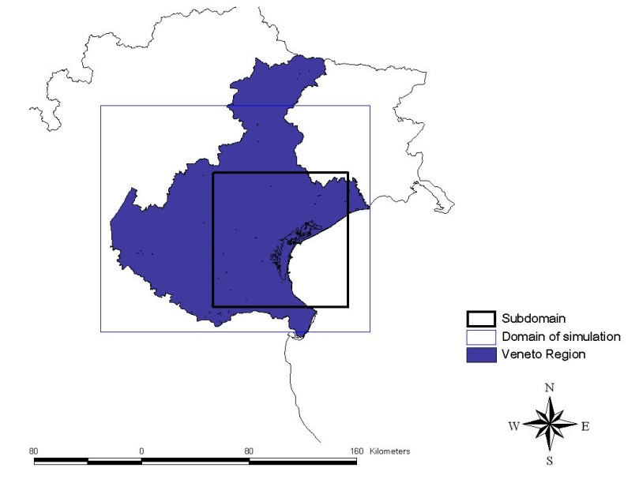

Figure 5.1: Veneto Region Domain.
The Veneto Region territory, and particularly the plane area, is characterized by an continue urbanization, spread over a country with a rural connotation and with a fairly dense network of small and medium-sized firms. In this contest, the Venice area is peculiar for the high concentration of relevant anthropogenic sources: the most important industrial site of Veneto, Porto Marghera, in which are located coal and gas fuelled power plants, the oil refinery and relevant chemical industries; the commercial and tourist Venice harbor; the major airport of Veneto; the more busy highways connections; the most populate municipally of Veneto. Therefore, regarding the subdomain of 100x100 km², other than road transport and domestic heating emissions (especially for NOx, PM and CO), also energy production, ships and harbor activities and industries (SO2, NOx) play an important role, as is showed in the bar diagrams in Figure 5.2. The total amount of anthropogenic emissions for the seven major pollutants in Ktones is reported in the Annex 5.

For Venice, the three most important anthropogenic emission source sectors per pollutant are the following (results refer to a domain size of 100km x 100km with spatial resolution of 2km x 2km and reference year 2008) (Figure 5.3):
CO: 1) Central heating (47.2%), 2) Road transport (43.9%), and 3) Industries (4.8%).
NOx: 1) Road transport (45.5%), 2) Industries (16.4%) and 3) Energy production (11.2%).
SO2: 1) Energy production (46.5%), 2) Ship/Harbor activities (25.2%) and 3) Industries (19.8%).
NH3: 1) Agriculture (97.7%), 2) Road transport (1.8%) and 3) Central heating (0.4%).
NMVOCs: 1) Solvent and other product use (54.4%), 2) Road transport (18.5%) and 3) Central Heating (18.3%).
PM10: 1) Central heating (38.5%), Road transport (24.5%), and 3) Non-road transport (without ship/harbor activities) (11.3%).
PM2.5: 1) Central heating (41.5%), Road transport (24.9%), and 3) Non-road transport (without ship/harbor activities) (12.6%).

Focusing on the maritime sector (ship and harbor activities) being a key emission source sector within APICE, the percentage contribution to total anthropogenic emissions is 0.3% for CO, 6.4% for NOx, 25.2% for SOx, 0.4% for NMVOCs, 7.1% for PM10 and 8.2% for PM2.5.

Figure 5.2: Anthropogenic emissions by sector.

Figure 5.3. Anthropogenic source sectoral contribution to pollutant emissions in Venice.
Figure 5.3. (continuation)

Figure 5.3. (continuation)

The estimation of biogenic emissions is strictly connected with the meteorology. So the amount of emissions used in the regional model for the APICE purposes will be specifically calculated for the simulation period. For this reasons, the data shown in the specific table in the annex, for January and July 2008, are reported only for comparison. These results must be considered preliminary because the processor, recently prepared, has to be tested.

- Summary Tables Describing Methodologies and Data Used for the Estimation of the Maritime Sector Emissions for Each Study Area

Table 6.1: Summary table for the inland waterways vessels (the ranges represent the different ship types, engine types or operational mode e.g. "maneuvering", "at sea", "in port")
 | Barcelona | Genoa | Marseille | Thessaloniki | Venice
Methodology | - | - | Derived from MEET methodology (Trozzi and Vaccaro 1998) | EEA, 2006 | -
Activity data | - | - | Fleet, movements, gross tonnage | Fleet, engine horsepower | -
Emission factors | - | - | Emission per fuel mass (MEET methodology; EEA, 2006) | Emission per KWh (EEA, 2006) | -
Range of CO emission factors used | - | - | 7400 – 99000 g/tn fuel | 4 – 8.38 g/KWh | -
Range of NOx emission factors used | - | - | 35000 – 87000 g/tn fuel | 6.3 – 14.4 g/KWh | -
Range of SO2 emission factors used | - | - | 20000*S g/tn fuelª | 254 – 271 g/KWhª | -
Range of NH3 emission factors used | - | - | - | 0.002 g/KWh | -
Range of NMVOCs emission factors used | - | - | 2300 – 22600 g/tn fuel | 0.95 – 3.82 g/KWh | -
Range of PM10 emission factors used | - | - | 1200 g/tn fuel | 0.3 - 2.22 g/KWh | -
Range of PM2.5 emission factors used | - | - | 1200 g/tn fuel | 0.28 - 2.09 g/KWh | -
ªS is the sulfur content of the fuel used.

Table 6.2: Summary table for the fish catching ships.
 | Barcelona | Genoa | Marseille | Thessaloniki | Venice
Methodology | - | - | - | EEA, 2006 | -
Activity data | - | - | - | Fleet, fuel consumption | -
Emission factors | - | - | - | Emission per fuel mass (Cooper and Gustafsson, 2004) | -
Range of CO emission factors used | - | - | - | 5336 g/tn fuel | -
Range of NOx emission factors used | - | - | - | 58362 g/tn fuel | -
Range of SO2 emission factors used | - | - | - | (20000 * S) g/tn fuelª | -
Range of NH3 emission factors used | - | - | - | 15 g/tn fuel | -
Range of NMVOCs emission factors used | - | - | - | 976 g/tn fuel | -
Range of PM10 emission factors used | - | - | - | 976 g/tn fuel | -
Range of PM2.5 emission factors used | - | - | - | 976 g/tn fuel | -
ªS is the sulfur content of the fuel used.

Table 6.3: Summary table for the passenger ships (the ranges represent the different ship types, engine types or operational mode e.g. "maneuvering", "at sea", "in port")
 | Barcelona | Genoa | Marseille | Thessaloniki | Venice
Methodology | EEA, 2009 (Tier 3 ship movement) | - | Derived from MEET methodology (Trozzi and Vaccaro 1998) | EEA, 2006 | Derived from MEET methodology (Trozzi, Vaccaro 1998)
Activity data | Fleet, stopovers, propelling power, load factor, time, fuel consumption, engine type, vessel phase | - | Fleet, Ship movements, time spent in operation modes, gross tonnage | Fleet, fuel consumption | Ship movements, time spent in operation modes
Emission factors | Emission per Kwh (EEA, 2009) | - | Emission per fuel mass (MEET methodology; EEA, 2006) | Emission per fuel mass (Cooper and Gustafsson, 2004) | Emission per fuel mass (EC, 2002) and for CO EEA, 2006
Range of CO emission factors used | - | - | 7400 – 99000 g/tn fuel | 9206 – 120000 g/tn fuelª | 7400 g/tn fuel
Range of NOx emission factors used | 1.6 – 14.7 g/Kwh | - | 23000 – 57000 g/tn fuel | 28000 – 44841 g/tn fuelª | 46000-77000 g/tn fuel
Range of SO2 emission factors used | - | - | 20000*S g/tn fuelª | (20000 * S) g/tn fuelª | 46000-54000 g/tn fuel
Range of NH3 emission factors used | - | - | - | 26 g/tn fuelª | -
Range of NMVOCs emission factors used | 0.3 – 1.8 g/Kwh | - | 2300 – 22600 g/tn fuel | 1671 – 23900 g/tn fuelª | 2000-6200 g/tn fuel
Range of PM10 emission factors used | 0.3 – 2.4 g/Kwh | - | 1200 g/tn fuel | 1500 - 4228 g/tn fuelª | 5000-9800 g/tn fuel
Range of PM2.5 emission factors used | - | - | 1200 g/tn fuel | 1500 - 4228 g/tn fuelª | 5000-9800 g/tn fuel
ªS is the sulfur content of the fuel used.

Table 6.4: Summary table for the cargo shipping (the ranges represent the different ship types, engine types or operational mode e.g. "maneuvering", "at sea", "in port")
 | Barcelona | Genoa | Marseille | Thessaloniki | Venice
Methodology | EEA, 2009 (Tier 3 ship movement) | - | Derived from MEET methodology (Trozzi and Vaccaro 1998) | EEA, 2006 | Derived from MEET methodology (Trozzi, Vaccaro 1998)
Activity data | Fleet, stopovers, propelling power, load factor, time, fuel consumption, engine type, vessel phase | - | Fleet, Ship movements, time spent in operation modes, gross tonnage | Fleet, operating time | Ship movements, time spent in operation modes
Emission factors | Emission per Kwh (EEA, 2009) | - | Emission per fuel mass (MEET methodology; EEA, 2006) | Emission per hour of operation (Cooper and Gustafsson, 2004) | Emission per fuel mass (EC, 2002) and for CO EEA, 2006
Range of CO emission factors used | - | - | 7400 – 99000 g/tn fuel | 2045 – 5063 g/tn fuel | 7400 g/tn fuel
Range of NOx emission factors used | 1.6 – 14.7 g/Kwh | - | 23000 – 57000 g/tn fuel | 61657 – 87136 g/tn fuel | 32000-92000 g/tn fuel
Range of SO2 emission factors used | - | - | 20000*S g/tn fuelª | (20000 * S) g/tn fuelª | 49000-54000 g/tn fuel
Range of NH3 emission factors used | - | - | - | 29 g/tn fuel | -
Range of NMVOCs emission factors used | 0.3 – 1.8 g/Kwh | - | 2300 – 22600 g/tn fuel | 919 – 1525 g/tn fuel | 1400-7800 g/tn fuel
Range of PM10 emission factors used | 0.3 – 2.4 g/Kwh | - | 1200 g/tn fuel | 2326 - 6667 g/tn fuel | 4400-10600 g/tn fuel
Range of PM2.5 emission factors used | - | - | 1200 g/tn fuel | 2326 - 6667 g/tn fuel | 4400 10600 g/tn fuel
ªS is the sulfur content of the fuel used.

Table 6.5: Summary table for the harbor operations
 | Barcelona | Genoa | Marseille | Thessaloniki | Venice
Methodology | - | - | - | Martin et al. 2007 | -
Activity data | - | - | - | Mass of handled material | -
Emission factors | - | - | - | Emission per mass of handled material (Martin et al. 2007) | -
Range of PM10 emission factors used | - | - | - | 2.211761 g/tn material | -
Range of PM2.5 emission factors used | - | - | - | 0.334924 g/tn material | -

- Synthesis

  - Comparison of Emission Results

The most important emission sectors in each city provide an indication of the anthropogenic activities that may have greater contribution to air pollution problems in urban scale. Regarding the CO emissions, in Thessaloniki and Genoa the road transport sector produces 67% and 77% of the emissions respectively while the industrial sector is responsible for the majority of CO emissions in Marseille (68%) and Barcelona (38.5%). In Venice, the central heating and the road transport sectors have an almost equal contribution to CO emissions (~45%). The road transport sector dominates the emissions of NOx in all the cities (contribution that can range from 34% to about 46%) except for Genoa in which the most important sectors are the energy production and non-road transport (including ship/harbor activities). The emissions of SO₂ are released in the atmosphere mainly from the industrial sector (Thessaloniki (63.5%), Genoa (85%), Marseille (38%)) while the energy sector generates almost half of the SO₂ emissions in Venice. In contrast, in Barcelona the non-road sector contributes with 46.2% in SO₂ emissions being the primary emission sector. The dominant sector of NH₃ emissions is the agriculture in Thessaloniki, Barcelona and Venice while the treatment of waste produces the majority of NH₃ emissions in Genoa (67%) and Marseille (61%). The use of solvents produces most of the NMVOCs emissions in Thessaloniki (35.7%), Barcelona (74.6%) and Venice (54.4%) while in Genoa the road transport (41%) and in Marseille the industrial sector (25%) play that role. Particle emissions are primarily produced by the road transport sector in Barcelona and Genoa, by the industrial sector in Thessaloniki and by the central heating in Venice. In Marseille, the industrial and road transport are both key sectors in the release of particulate matter emissions.

Regarding the maritime sector, the pollutants that are mainly emitted are NOx and SO₂. In Thessaloniki, 22.9% and 27.2% of NOx and SO₂ emissions are produced from the maritime sector being the 3rd and 2nd emitting source respectively. In Marseille, the maritime sector is the 3rd contributing emitting source to SO₂ emissions with an important percentage contribution of 20% and the 4th one to NOx emissions with a contribution of 17%. In Venice, the respective contribution is high for SO₂ (25.2% , 2nd contributing emitting source) and small for NOx (6.4%). In Barcelona also, the contribution of the maritime sector to NOx emissions is estimated to be generally small (8.3%). As regards the emissions of particles, the maritime sector has a 14% share in PM₁₀ emissions in Barcelona. In Venice the corresponding share is 7.1% for PM₁₀ and 8.4% for PM_{2.5}. In the other cities, the contribution is mostly below 5%. Note that for Genoa, only total emissions of the non-road transport sector are available and as a result an assessment of the share of the maritime sector to pollutant emissions is not possible.

Tables 7.1 presents the calculated emissions from the maritime sector for all pollutants and cities studied. For all pollutants, except for particulate matter, the Marseille emissions are the highest. Thessaloniki and Venice are respectively the 2nd and 3rd emitting areas in CO and SO₂ emissions. Regarding NOx emissions, Thessaloniki is 2nd in the rank (after Marseille). However, Thessaloniki’s maritime NOx emissions can be considered comparable to those of Marseille. Barcelona is the 3rd in the rank of NOx emissions and Venice follows. Maritime PM emissions in Barcelona are almost double of those in Venice and more than 3 times of those in Marseille and Thessaloniki of the maritime PM emissions.

  - The Maritime Sector Methodology

The primary methodology which is used for the estimation of emissions from the shipping activities in the cities under study was originally presented by Trozzi and Vaccaro (1998) in the framework of the MEET project. This methodology was later adapted in the EMEP/CORINAIR European emission inventory handbook (EEA, 2006). Consequently the emissions from ships are determined implementing the following equation:

where: E_{i} is the ship emission of the pollutant i. The total emissions E_{i} are the sum of the emissions of each ship type k, fuel type j, engine type l and operating phase m.

where FC_{jkm} is the daily consumption of fuel type j of the ship type k in the operating mode m, p_{m,k} is the fraction of maximum engine power in the operating phase m of the ship type k, t_{jklm} is duration of the navigation of the ship of type k having an engine type l using fuel type j in the operating mode m and finally EF_{ijlm} is the average emission factor of pollutant i from fuel type j in the engines type l of operating mode m. A variation of the above equation uses the vessel’s installed engine power instead of the fuel consumption in order to calculate the emissions. In that case, the emission factor corresponds to the mass of pollutant i per kilowatt of installed engine power and hour rather than per mass of consumed fuel. This approach is being used for the compilation of the emission inventory of Barcelona and for the estimation of emissions from the inland waterways vessels in Thessaloniki.

The calculation is completed for each vessel type k. The general types of vessels in the EMEP/CORINAIR methodology are: General Cargo, Dry Bulk Carriers, Liquid Bulk Carriers, Containers, Ro-Ro, Tugs, Fish catching ships, Passenger and other type of vessel. The activity information can be provided as number of vessels per vessel type (e.g. in the emission inventories of Thessaloniki and Barcelona) or information could be available for all individual ships of the fleet (e.g. in the emission inventories of Venice and Marseille). Fuel types used are bunker fuel oil (BFO), marine diesel oil (MDO), marine gas oil (MGO) and gasoline (GF). The moving phases of the ships can be distinguished in cruising, maneuvering and hotelling (the emission inventory of Genoa also uses tank/loading unloading phase). The engine types used in ships can be separated in slow, medium, high speed and gas turbines.

The fuel consumption (or the installed engine power in the case of the emission inventory of Barcelona) of each vessel type (or for individual vessels) is a function of its gross tonnage (GT). The fuel consumption or the installed engine power from the GT are given by relevant equations. Τhe emission inventory of Barcelona uses a set of equation for different years based on the EMEP/CORINAIR emission inventory handbook, March 2011 version. In the emission inventories of Thessaloniki, Marseille and Venice the equations presented in the EMEP/CORINAIR emission inventory handbook (EEA, 2006), are being used. In the case of the Thessaloniki and the Barcelona emission inventories, the GT values are provided as total GT from all vessels of each type k while in the emission inventories of Venice and Marseille the GT is available for each individual ship in the database. The fraction of maximum power of engines in the emission inventory of Barcelona are those of the EMEP/CORINAIR emission inventory handbook, June 2010 version, while in the emission inventories of Thessaloniki, Marseille and Venice those presented in the EMEP/CORINAIR emission inventory handbook (EEA, 2006) are used. For the duration of the cruising phase, the distance travelled inside the study area and typical cruising speed values for each vessel type (EEA, 2006) are used for the emission inventories of Thessaloniki and Marseille. The maneuvering phase duration in the emission inventory of Marseille used the same average speed reduced by half. Regarding the ship engine type, the emission inventory of Thessaloniki assigned to all ships types, slow engines except fish catching ships, tugs and passenger ships (medium speed engines) and high speed ferries (high speed engines). For the emission inventory of Marseille the information presented in chapter 3 is used. The split factors of the various vessel types which is used in the Barcelona emission inventory in order to split the fleet in different engine types is taken from the EMEP/CORINAIR emission inventory handbook, June 2010 version. The same is also used in the Barcelona emission inventory to split the fleet in various fuel types.

For the emission inventory of Barcelona, the emission factors of the EMEP/CORINAIR emission inventory handbook, June 2010 version are used. The emission factors used in the emission inventory of Venice are those of the Entec UK Ltd on behalf of the European Commission (EC, 2002) while the CO emission factors are taken from the EEA (2006). For Thessaloniki, the set of emission factors derive from Cooper and Gustafsson (2004) except from the inland waterways vessels which derive from EEA (2006). Marseille and Genoa uses the EEA (2006) emission factors.

The full ranges of pollutant emission factors used for the calculation of emissions from cargo and passenger vessels (corresponding to the various characteristic of the vessels (engine types, engine loads etc.), fuels used and operating modes) are presented in Table 7.2 for the cities studied. A constant CO emission factor (7400 gr/tn) is used for the emission inventory of Venice being equal to the lowest value of the CO emission factors used for the emission inventory of Marseille, while in the emission inventory of Thessaloniki the lowest emission factor value is 3 times less (2045 gr/tn). The CO emission factor could reach up to 120000 gr/tn for the hotelling mode, although the maneuvering and hotelling modes constitute a small part of the emissions. The range of NOx emission factors is comparable for Thessaloniki and Venice and is higher than the corresponding range for Marseille. The emission factors of SO₂ are practically the same among the cities given that the sulfur content value used is around 2.3% - 2.7%. A wide range of NMVOCs emission factors is used for the inventories of Marseille (2300 – 22600 gr/tn) and Thessaloniki (919 – 23900 gr/tn). The range is smaller for Venice (1400 – 7800 gr/tn). The lowest value of the emission factors for the estimation of particulate matter emissions is used in the emission inventory of Marseille (1200 gr/tn) while the highest ones (4400 – 10600 gr/tn) are used for the Venice emission inventory. Note that the emission factors for the emission inventory of Barcelona cannot be compared to the emission factors used in the inventories of the other cities because the reference units are different.

In the emission inventory of Thessaloniki, in addition to the emissions from ships, the emissions from the handling of materials and the vehicles in operation inside the harbor area were estimated. The methodology of Martin et al. (2007) was used. The mass of handled material per material type as well as the fleet of the operating vehicles in the harbor were provided by the Thessaloniki Port Authority S.A.

Table 7.1: The maritime sector emissions for the cities under study.
 | Emissions (in tons)
Pollutant | Barcelona | Genoa | Marseille | Thessaloniki | Venice
CO | - | - | 16585 | 1258 | 495
NOx | 6590 | - | 11840 | 10680 | 4007
SO2 | - | - | 16349 | 4529 | 3812
NH3 | - | - | - | 2.2 | -
NMVOCs | 719 | - | 3601 | 202 | 345
PM10/PM2.5 | 1021/- | - | 305/305 | 297/284ª | 551/551
ª14.1 tonnes of PM10 and 2.1 tonnes of PM2.5 originate from the handling of materials in the harbor area.

Table 7.2: Range of emission factors used for the estimation of the maritime sector emissions for the cities under study. The ranges correspond to passenger and cargo vessels, their individual characteristics, fuels used and operating modes.
 | Range of emission factors used
Pollutant | Barcelona (g/Kwh) | Genoa (-) | Marseille (g/tn) | Thessaloniki (g/tn) | Venice (g/tn)
CO | - | - | 7400 – 99000 | 2045 – 120000 | 7400
NOx | 1.6 – 14.7 | - | 23000 – 57000 | 28000 – 87136 | 32000 – 92000
SO2 | - | - | 20000*Sª | 20000*Sª | 46000 – 54000
NH3 | - | - | - | 29 | -
NMVOCs | 0.3 – 1.8 | - | 2300 – 22600 | 919 – 23900 | 1400 – 7800
PM10 and PM2.5 | 0.3 – 2.4 | - | 1200 | 1500 - 6667 | 4400 – 10600
ªS is the sulfur content of the fuel used.
Annexes

Excel files with the emission data for each study area:

Annex 1: Emission_Inventory_Barcelona.xls

Annex 2: Emission_Inventory_Genoa.xls

Annex 3: Emission_Inventory_Marseille.xls

Annex 4: Emission_Inventory_Thessaloniki.xls

Annex 5: Emission_Inventory_Venice.xls

References

- ARPAV, 2007. A cura di M. Rosa, S. Pistollato:, C. Zemello. Le emissioni da attività portuale.
http://www.arpa.veneto.it/dapve/docs/Relazione_tecnica_emissioni_portuali.pdf
- APV, 2010. Autorità Portuale di Venezia, Relazione Annuale 2009. http://www.port.venice.it/files/document/documenti-istituzionali/2010/apvrelazioneannuale2009n.pdf
- APV, 2011. Autorità Portuale di Venezia, Relazione Annuale 2010. http://www.port.venice.it/files/document/documenti-istituzionali/2011/apvrelazioneannuale2010.pdf
- Bessagnet B., L. Menut, G. Curci, A. Hodzic, B. Guillaume, C. Liousse, S. Moukhtar, B. Pun, C. Seigneur, M. Schulz, 2008. Regional modeling of carbonaceous aerosols over Europe - Focus on Secondary Organic Aerosols Journal of Atmospheric Chemistry, 61, 175-202.
- Caserini S., A. Fraccaroli, A.M. Monguzzi, M. Moretti, A. Giudici, G. Volpi, 2002. The INEMAR database: a tool for regional atmospheric emission inventory. Proc. IEMSS 2002, 1, 186-191.
- Caserini S., A. Fraccaroli, A.M. Monguzzi, M. Moretti, A. Giudici, E. Angelino, G. Fossati, 2005. L’INVENTARIO DELLE EMISSIONI IN ATMOSFERA IN LOMBARDIA:STATO DELL’ARTE E PROSPETTIVE. IA Ingegneria Ambientale vol. XXXIV n. 5 maggio 2005.
- CEREN (Centre d’Etudes et de Recherches Economiques sur l’Energie), 2001 – Connaissance des parts de marche des differentes energies pour le chauffage et la climatisation en 2000 pour la region Provence Alpes Cote d’Azur et ses departements – Secteur Tertiaire.
- CITEPA (Centre Interprofessionnel Technique d’Etudes de la Pollution Atmosphérique), 1999 - Guide méthodologique des émissions dans l'atmosphère d'une zone aéroportuaire.
- CITEPA (Centre Interprofessionnel Technique d’Etudes de la Pollution Atmosphérique), 2002 - Facteur d'émission du protoxyde d'azote pour les installations de combustion et les procédés industriels.
- CITEPA (Centre Interprofessionnel Technique d’Etudes de la Pollution Atmosphérique), 2004 - Organisation et méthodes des inventaires nationaux des émissions atmosphériques en France - édition 2.
- CITEPA (Centre Interprofessionnel Technique d’Etudes de la Pollution Atmosphérique), 2008 - Organisation et méthodes des inventaires nationaux des émissions atmosphériques en France - édition 4.
- CITEPA(Centre Interprofessionnel Technique d’Etudes de la Pollution Atmosphérique), 2010 – National inventories of air emissions in France : Organisation and methodology – CITEPA / OMINEA report – updated February 2010.
- Cooper DA., T. Gustafsson, 2004. Methodology for calculating emissions from ships: 1. Update of emission factors, Report series SMED and SMED & SLU 4. Available at http://westcoastcollaborative.org/.
- CRIGE (Centre Régional de l’Information Géographique), 2004 – Occupation du sol 1999 Provence Alpes Cote d’azur, version 3 – Guide technique.
- Dipartimento Provinciale di Venezia di A.R.P.A.V., “Le emissioni da attività portuale” - febbraio 2007,
http://www.arpa.veneto.it/dapve/docs/Relazione_tecnica_emissioni_portuali.pdf
- DRIRE (Direction Régionale de l’Industrie, de la Recherche et de l’Environement), 2007 - Recensement des stations services et ventes annuelles par station.
- EC, 2002. Quantification of emission from ships associated with ship movements between ports in the European Community. Final Report. July 2002. http://ec.europa.eu/environment/air/pdf/chapter2_ship_emissions.pdf
- EEA (European Environment Agency), 1999. EMEP/CORINAIR - Emission inventory guidebook.
- EEA (European Environment Agency), 2004. EMEP/CORINAIR - Atmospheric emission inventory guidebook- Small combustion installations
- EEA (European Environment Agency), 2006. EMEP/CORINAIR Emission Inventory Guidebook 2006. (EEA Technical Report no.30). Available at http://reports.eea.europe.eu/EMEPCORINAIR4.
- EEA (European Environment Agency), 2007. Emission Inventory Guidebook, Technical Report N°16/2007.
- EEA (European Environment Agency), 2009. EMEP/EEA air pollutant emission inventory guidebook 2009. (EEA Technical Report no. 9/2009). Available at http://www.eea.europa.eu/publications/emep-eea-emission-inventory-guidebook-2009
- EPA (United States Environmental Protection Agency), 1998a. Locating and estimating air emissions from sources of polyciclic organic matter.
- EPA (United States Environmental Protection Agency), 1998b. Locating and estimating air emissions from sources of benzene.
- Gong S. L., 2003. A parameterization of sea-salt aerosol source function for sub- and super-micron particles. Global Biogeochemical Cycles, 17, 1097-1104.
- Guenther A., T. Karl, P. Harley, C. Wiedinmyer, P.I. Palmer, C. Geron, 2006. Estimates of global terrestrial isoprene emissions using MEGAN (Model of Emissions of Gases and Aerosols from Nature). Atmospheric Chemistry and Physics, 6, 3181–3210.
- Karl M., A. Guenther, R. Köble, A. Leip, G. Seufert, 2009. A new European plant-specific emission inventory of biogenic volatile organic compounds for use in atmospheric transport models. Biogeosciences, 6, 1059–1087.
- Markakis K., T. Giannaros, A. Poupkou, N. Liora, D. Melas, M. Sofiev, J. Soares, 2009. Evaluating the impact of particle emissions from natural sources in the Balkan region. European Aerosol Conference 2009, 6-9 September 2009, Karlsruhe, Germany.
- Markakis K., E. Katragkou, A. Poupkou, N. Liora, T. Giannaros, D. Melas, 2011. MOSESS: A new emission model for the compilation of model-ready emission inventories. Environmental Science and Policy (submitted).
- Martin F., M. Pujadas, B. Artinano, F. Gomez-Moreno, I. Palomino, N. Moreno, A. Alastuey, X. Querol, J. Basora, J.A. Luaces, A. Guerra, 2007. Estimates from atmospheric particles emissions from bulk handling of dusty material in Spanish harbors. Atmospheric Environment, 41, 6356-6365.
- Monahan, E. C., D. E. Spiel, K. L. Davidson, 1986. A model of marine aerosol generation via whitecaps and wave disruption, in Oceanic White-caps, edited by E. C. Monahan and G. MacNiochaill, pp. 167 – 193, D. Reidel, Norwell, Mass.
- NATAIR, 2007. Ing. Rainer Friedrich. Improving and applying methods for the calculation of natural and biogenic emissions and assessment of impacts to the air quality. Publishable final activity report. SIXTH FRAMEWORK PROGRAMME FP6-2003-SSP-3 – Policy Oriented Research SPECIFIC TARGETED RESEARCH OR INNOVATION PROJECT. Proposal No.: 513699. Available at http://natair.ier.uni-stuttgart.de/.
- OFEFP (Office Fédéral de l’Environnement, des Forêts et du Paysage), 1995 - Coefficients d'émission des sources stationnaires.
- OFEFP (Office Fédéral de l’Environnement, des Forêts et du Paysage) 2000 - Coefficients d'émission des sources stationnaires.
- Poupkou A., T. Giannaros, K. Markakis, I. Kioutsioukis, G. Curci, D. Melas, C. Zerefos, 2010. A model for European biogenic volatile organic compound emissions: Software development and first validation. Environmental Modelling and Software, 25, 1845-1856.
- Sambat S., J. Theloke, R. Friedrich, N. Allemand, 2004. Bibliographic study concerning the speciation of NMVOC within the project INTERREG III. IER – Institut für Energiewirtschaft und Rationelle Energie-anwendung, Universität Stuggart. CITEPA - Centre Interprofessionnel Technique d’Etudes de la Pollution Atmosphérique. Novembre 2004.
- Sofiev M., J. Soares, M. Prank, G. de Leeuw, K. Kukkonen, 2011. A regional-to-global model of emission and transport of sea salt particles in the atmosphere. Journal of Geophysical Research (in press).
- Trozzi C. and Vaccaro R., 1998. Methodologies for estimating air pollutant emissions from ships. Techne report MEET RF98.
- Visschedijk A.J.H., P.Y.J. Zandveld, H. Denier van der Gon, 2007. High Resolution Gridded European Emission Database for the EU Integrate Project GEMS, TNO-report 2007-A-R0233/B.
- Webb R.W., C.E. Rosenzweig, E.R. Levine, 2000. Global Soil Texture and Derived Water-Holding Capacities. Data set available on-line from Oak Ridge National Laboratory Distributed Active Archive Center, Oak Ridge, Tennessee, U.S.A.
URLs

- IIASA 2001. RAINS-Europe Project.
http://www.iiasa.ac.at/~rains/Europe/home_text.html
- INEMAR Veneto :
http://www.arpa.veneto.it/aria_new/htm/inventario_emissioni_aria.asp?2
- INEMAR Wiki Fonti
http://www.inemar.eu/xwiki/bin/view/FontiEmissioni/RicercaMSA
- INEMAR Wiki http://www.inemar.eu/xwiki/bin/view/InemarWiki/

