Traffic of the Venice Port

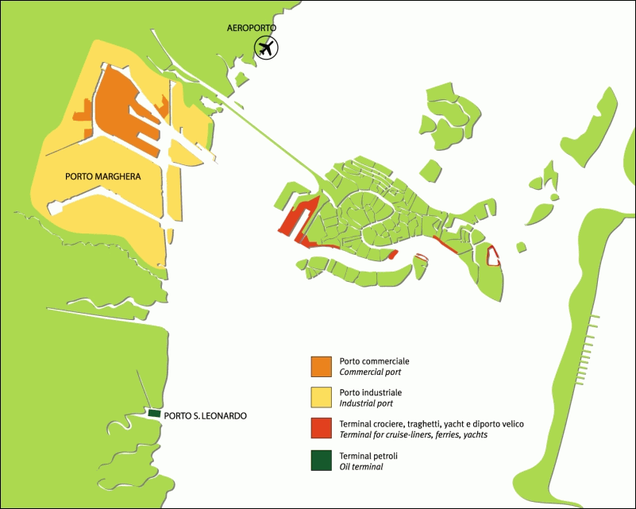
Traffic | Total tonnage
General cargo | 7.186.540
Dry bulk | 6.328.905
Liquid bulk | 11.674.399
TOTAL | 25.189.844
TEU | 369.474
Number of Vessel | 4.294
Number of passengers | 1.888.670

